Project

*WEB701 - Implement your website and explore and develop on the edge of web tech space.*

Jackson Hayes

NMIT ID - 13521772

S2 2024

Table of Contents

Design – Milestone One 4

Project Brief 4

Site Goals 4

Mission Statement 4

Short & Long Term Goals 4

Intended Audience 5

Why will people come to the website? 6

User Experience 6

Audience Analysis 6

Scenario One 7

Scenario Two 8

Scenario Three 9

Competitive Analysis 10

Summary of Analysis 16

Site Content 16

Content and Functional Requirements 16

Grouping and Labeling 17

Site Structure 18

Metaphors 18

Site Structure Listing 19

Architectural Blueprint 20

Define Navigation 21

Visual Design 22

Wireframes 22

Mockups 27

User Stories 31

CRUD Analysis 33

Backlog List 34

Evaluate – Milestone Two 37

Purpose of Web Frameworks 37

Common Web Framework Features 37

Features Relevant to the Scenario 38

Emerging Web Technologies 39

Describe and Identify an Emerging Web Technology 39

Selection and Implementation Analysis 41

Impact on Internet Users 42

Web Framework Evaluation and Comparison 43

1. Registration / Login 43

2. Voucher Transaction 49

3. Database Connection 54

Framework Recommendation 60

React Pros and Cons 61

Angular Pros and Cons 61

Justification for the MEAN Stack 61

Conclusion 63

Develop – Milestone Three 63

Part one: Functional Implementation of your website using your selected framework. 63

Register / Login 63

Donation Listing & Voucher Redemption 63

Interactive Elements 63

Token Transaction 64

Data Storage / Retrieval 64

Part two: research and implement emerging technology into your website 64

Documentation for Recipe Generator 64

References 65

# Design – Milestone One

## Project Brief

The Grow & Give charity is a food donation charity in the Nelson region who offer local fresh produce to the community. We need a website for the Nelson region for members of the charity to provide fresh produce and excess product that is still usable. The charity is initially aimed at donating locally sourced fresh fruit, vegetables and berries but has potential to expand into all food item donations in the long-term.

The purpose of the new website is to help with the distribution of the service or product by members of our charity to customers. Like a “food bank”, the website lets members register and describe the service or products they are providing, the number and frequency of the offerings. The website lets members of the community (beneficiaries) access the service, by providing tokens that can be “spent” in the service. To achieve our goal, we would like to have an online token function on our website that let a beneficiary access a limited number of tokens, for example the system needs a mechanism that verifies that a member of the community is accessing the service and that the token belongs to a particular community member. The website needs some homepage text about general information of our products and services such as: types, characteristics, quality factor, usage and benefit.

We require the following features on the website:

1. Charity members and beneficiaries can register, log in and administer their own accounts.
2. Members use the website to register their products and services, and beneficiaries use the system to acquire tokens.
3. Interactive element(s) that engages the website user.
4. The system provides an interface that the members can use to accept a token in a transaction.

## Site Goals

### Mission Statement

The Grow & Give charity service website aims to bridge the gap between local farmers/growers and members of the community in need by providing a platform for donating and distributing excess fresh berries and usable produce. The goal is to promote healthy eating, support the local businesses and agriculture, and ensure that no one in the community goes without easy access to nutritious foods.

### Short & Long Term Goals

1. The website is initially aimed at donations in the form of fresh produce like berries or vegetables as there is a lot of local agricultural farms/businesses that could contribute to the charity. A long term goal of the website/charity would be to gradually move to more of a foodbank style charity with donations of any type of food being accepted to boarded the reach and improve the amount of donations the charity is giving. This could then be used by restaurants or bakeries that have excess products at the end of the day that are still good to eat and could be offered for donation.
2. To create a platform that can facilitate donations from local berry growers, farmers or supermarkets to donate fresh berries or excess produce that is still usable. The initial and early-stage goals is to have a working system with distribution being a ‘click-and-collect’ approach. A long-term goal is enabling a distribution service for these donations to be delivered directly to community members that are in need which will also improve the accessibility of the charity service by being accessible to those who may not be able to collect the donation personally.
3. To promote healthy eating and ensure members of the community have easy access to fresh, locally sourced and nutritious produce. The long-term goal of this is to have a website and platform to educate the community about health benefits and various uses of prouce through informative content and recipes.
4. Supports local agriculture by creating a connection between local growers/farmers and the community through their donation service. The charity and website responsible for giving donations will be another way of highlighting quality produce that is locally grown, further promoting local farmers.
5. The website will implement a fair system that utilizes vouchers to ensure equal distribution of the donations, allowing beneficiaries to access a limited number of vouchers to acquire the donated produce. Ideally in the long-term, there could be the implementation of some verification mechanisms to make sure vouchers are only given to registered community members to main the integrity and transparency of the charity organization.
6. Although it is a charity and website aimed at giving locally sourced produce donations to community members in need, there could also be a long-term goal of adjusting this to allow for anyone to receive donations which would tie into the last point previously mentioned of having a system to verify beneficiaries and prioritize the community members who are in need. This could mean that those in need get the fresh produce, while others only have access to the excess produce in limited supply.

### Intended Audience

There are 2 main groups in the intended audience but also contains many subgroups that the website and charity apply to. The first main group are the local farmers, growers and businesses involved berry farming/harvesting and are interested in donating their produce to the community in need. The second group are community members in need. This includes individuals and families who would benefit from receiving fresh produce.

While it is a charity service and website aimed at donating fresh local produce to community members in need by providing food that is nutritious, healthy and like by many, it can also be a place for other groups of people to receive local produce. These other groups include but aren’t limited to:

1. General public/Community supporters
2. Health-conscious people
3. Commercial hospitality businesses (Restaurants, Cafes, Bakeries, etc.)

### Why will people come to the website?

1. Donators will come to the website to easily register and manger their berry donations which will contribute to the community and people in need. This will also give the donors visibility and goodwill for their contributions
2. Beneficiaries will come to the website to access fresh and nutritious produce, learn and understand about the health benefits of eating healthier whole foods and be apart of a supportive community.
3. Health-conscious people and/or the general public can use the website to apply for excess produce that is still usable (making sure the community in need are prioritized first) or to find recipes, health tips and information on the benefits of eating clean food.
4. Supports will come to the website to support local agricultural and community enhancing projects that aim to give to people in need.

## User Experience

### Audience Analysis

As mentioned in the section above, the intended website audience is almost split into two groups with the first group consisting of produce/berry donators and beneficiaries (community members in need) and is the primary reason for the website. The second group can be seen as anyone else who would use the website including but not limited to the general public, businesses, supporters, health-conscious people, etc. Although both groups for the websites intended audience share an equal weight of importance in the development of the website, it is still a charity service which primarily aims to help community members in need.

Here is a more in-depth analysis of the website intended audience:

* **Local Berry Growers/Farmers:** Individuals and businesses involved in berry farming with excess produce who are wanting to donate to community members in need.
* **Beneficiaries:** Community members in need of healthy whole foods including low-income families/individuals, elderly members and individuals with limited access to nutritious food.
* **Health-conscious individuals/General public:** People interested in the benefits of healthy eating and looking for recipes or wellness information. A long term goal for the website is to allow others to apply for fresh produce assuming community members in need are prioritized first. (This concept is still a work in progress)
* **Community supporters:** individuals and businesses that want to support local agriculture, sustainable practices and projects that help people of the community in need. Businesses who are also looking to partner with the charity for evens and promotions.

### Scenario One

**Persona:** John the Berry farmer

* **Name:** John
* **Age:** 45
* **Occupation:** Berry Farmer
* **Background:** John has been the owner and operator of a local family run berry farm for the last 20 years. He is dedicated to sustainable practices and often has surplus berries or produce that isn’t quite up to quality standards that he wants to donate to reduce waste and support the community in need.
* **Goals:**
  + Reduce the amount of excess produce
  + Support the community and members in need
  + Increase and gain positive visibility of his business/farm
* **Pain Points:**
  + Not having a way to manage surplus produce
  + Finding reliable and ethical distribution services to ensure donations reach those who need them most
  + Balancing time between his job and coordinating donations

*“As a berry farmer, I want to be able to easily register and manage my donations so that I can contribute to excess produce without hassle. I want to donate my surplus berries to the community to help reduce wasted food and support local families/individuals in need”*

John hears about the Grow & Give charity service and sees it as an excellent opportunity to donate his excess berries. As a user of the Grow & Give web app, John would like to do the following:

* Register as a donor with his contact information, including business name, location and types of product he typically grows.
* Be able to list the types and quantities of berries available for donation, providing information for pickup or handling instructions
* Manage any listings through a dashboard where he can update the quantities, pickup schedule, etc.

The outcome of John using the charity website to successfully donate his surplus berries means he feels gratifies knowing that his what would be wasted produce is helping those in need and contributing to the community. Additionally, his farm gains a positive reputation for being involved with charity and helping reduce food waste.

### Scenario Two

**Persona:** Sarah the single mother

* **Name:** Sarah
* **Age:** 32
* **Occupation:** Part-time retail worker
* **Background:** Sarah is a single mother of two children. She works part-time and lives week to week when it comes to managing her funds. She is always looking for ways to provide healthy food for her children on a tight budget.
* **Goals:**
  + Provide healthy food for her and her family
  + Manage on a tight budget while ensuring her children eat well
* **Pain Points:**
  + Limited access to affordable fresh and nutritious produce
  + Balancing work, childcare and meal preparation
  + Finding reliable sources of healthy food on a tight budget

*“As a single mother and part time worker I sometimes struggle to provide nutritious and healthy food for my family. I want to apply for vouchers so I can get regular access to fresh produce when needed so that my family can live a healthy lifestyle instead of eating junk food.”*

Sarah learns about the Grow & Give charity service and is excited to take the opportunity to receive fresh produce for her and her children. As a user of the Grow & Give web app, Sarah would like to do the following:

* Sign up and register a beneficiary account that includes her details, contact information and verifies her eligibility for the donation service
* See the available vouchers she can claim which allows her to request fresh berry donations
* Browse existing listings of available produce from local donors
* Redeem a voucher to request an order and receive details about the pickup location and scheduled times (If applicable)
* Have access to recipes and/or health tips on the website to make the most of the fresh produce

By Sarah using the Grow & Give charity website, she can successfully and easily acquire fresh health foods for her family through the donation platform. She will feel relief and gratitude for the support, know that she can provide healthy food for her children without pushing her budget. This will bring a positive experience and encourage her to continue using the service while she needs it.

### Scenario Three

**Persona:** Lisa the Bakery manager

* **Name:** Lisa
* **Age:** 38
* **Occupation:** Bakery Manager
* **Background:** Lisa has been running a small local bakery for the last 10 years where she originally started as a cake decorator and worked her way up to management. She is passionate about baking, helping and being involved with the community. Her bakery often has excess produce at the end of the week due to slow sales or over ordering of ingredients and she hates to see good food go to waste. Lisa wants to contribute to the community by donating her surplus produce (berries and fruit) to those in need.
* **Goals:**
  + Reduce food waste by donating excess produce
  + Support the community and members in need
  + Get a positive reputation and grow her bakery’s image
* **Pain Points:**
  + Not having a way to manage excess produce/ingredients
  + Finding reliable channels to ensure the donations reaches those in need
  + Lack of time to coordinate personal donation services effectively.

As a business owner in the food/hospitality industry, I want to donate any excess ingredients or possibly baked goods that did not sell so that I can support and give back to the community while reducing food waste.

Lisa hears about the Grow & Give donation charity and is excited to finally have the possibility of donating her bakery’s surplus produce. She visits the website and quickly sees an option for businesses to register as donors for the charity. As a user of the Grow & Give web app, Lisa would like to do the following:

* A way for her to register as a donor, which would include a form for her to enter in relevant details, including business name, location and types of donations she has to offer.
* Listing the types and quantities of excess food items she has available to donate for each day with specific pick up locations and times.
* A way for Lisa to manage her donations via a dashboard and see her listings, where she can update, remove or add quantities or product type.

By Lisa using the Grow & Give web app to donate her bakery’s surplus ingredients and baked goods (In a future version of the website) She will feel fulfilled and satisfied knowing that any excess produce is contributing to a good cause by helping those in need within the community. Additionally, her bakery should gain a positive reputation for being involved in a community focused charity and reducing food waste.

### Competitive Analysis

Some of the main competitors for the proposed charity service include existing food bank services, grocery delivery services and potentially community programs that give donations. The Grow & Give website plans on differentiating itself from its competitors by combing aspects of the strengths of each while addressing and taking into consideration their weaknesses. The platform focuses on fresh produce and operates on a donation-based model which ensures community members have access to healthy food. The voucher-based system could be implemented similarly to the foodbank project website, where instead of specific product purchase, the user can redeem a package using a voucher.

In more detail:

* **Food bank services:**
  + Food banks are a significant competitor as they are usually established organizations that donate and provide free food to those in need which is a very similar goal to my proposed charity idea. They will also have well established networks with donors and be known for recommendations. Food banks typically offer a wider range of food items, including canned goods, dry foods, and fresh produce which caters to a wider range of people.
* **Grocery delivery services:**
  + Grocery delivery services such as local supermarket delivery options or privately run businesses aren’t necessarily the biggest competitors against a food bank style charity organization due to groceries still needing to be purchased but should still be considered a competitor since it could share a similar goal of getting food and groceries to their customers. If we take the user story and persona of ‘Sarah the single mother’ I could see grocery delivery services being a competitor and possible first option as it would save Sarah the time and effort to personally get groceries and can all be done at an easy convenience.

Here are some links to New Zealand based charities/business websites which were used to analyze potential competition for the Grow & Give charity. The first two are food donation charities and the last one being a grocery deliver service:

<https://www.foodbank.org.nz/>

<https://www.nelsoncommunityfoodbank.org.nz/>

<https://www.teddy.nz/>

**The Foodbank Project NZ:**

The website itself is very basic in terms of visual design and user interface but that could have also been done with the purpose of remaining simple to use and focus on the goal of the website rather than the visual aspect. The user experience is relatively straightforward, with navigation feeling easy and having clear to read text throughout the website. I believe a strength of the Foodbank project website is the flow of the site, with the landing page containing a brief description of what the project is about and how it works and then has ways to donate and contribute below that. Additionally, the easy to use navigation links make it easy for a user to find what they’re looking for without getting lost, whether it be wanting to donate, get support, or just learn about how it works.

The Foodbank Project website is unique in the fact that it acts as a grocery delivery service but instead of receiving the groceries, they get donated to a foodbank and contribute to food packages given to people in need. The idea of this layout is quite a good idea in my opinion as users get the benefit of choosing what they want to donate specifically and/or how much they would like to donate/spend to contribute. Similarly to a long-term goal of the Grow & Give charity web app, the Foodbank project has a dedicated page filled with different healthy recipes or creative ideas that are budget friendly which helps to broaden their target audience and cater to more than just donors and beneficiaries.

One of their weaknesses in my opinion is the lack of visual design or colour throughout the website and overall looks very bland. While there is nothing wrong with a minimal design for websites, I feel as if there could be more done with the visual design of things to keep the user engaged and wanting to use the website.

*Screenshots for reference below:*

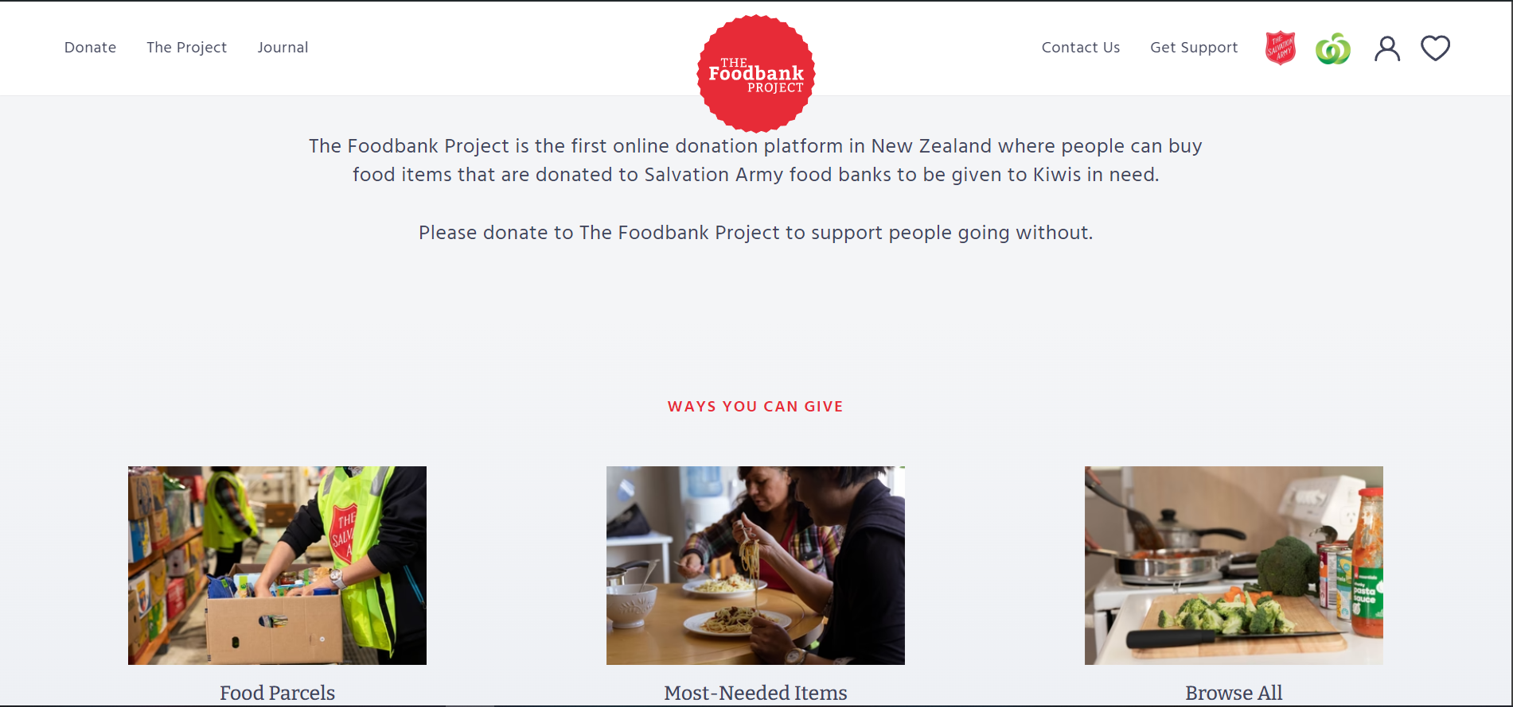

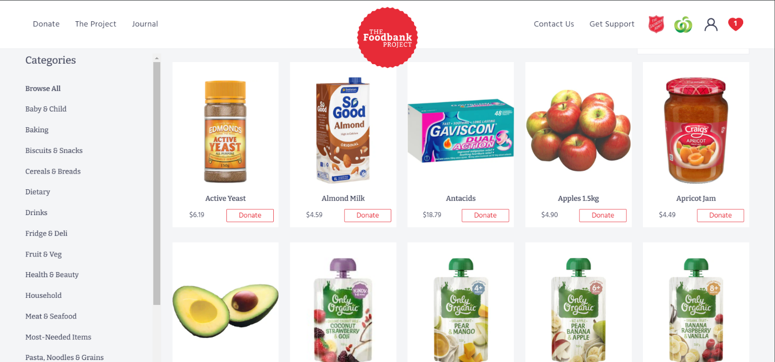

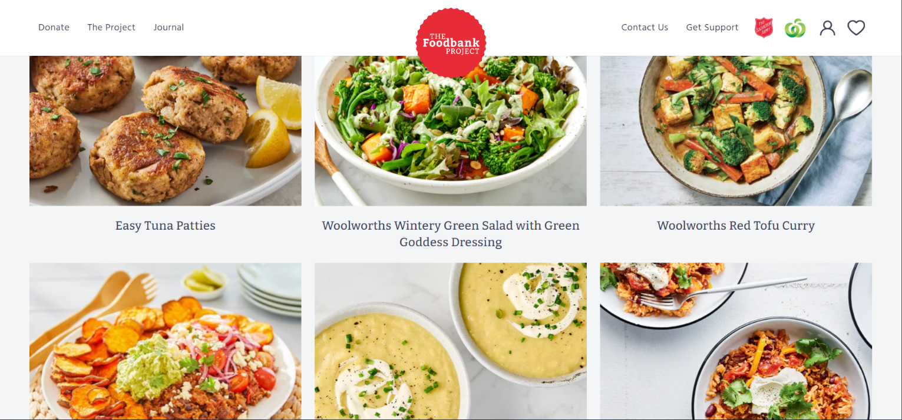

**Nelson Community Food Bank:**

The Nelson Community Food Bank website follows a similar approach to the previous website (The Foodbank Project) by having a good description and ‘about us’ section on the landing page with further information regarding reputative supporters and how to get started as a donor/beneficiary. I find that the initial UX/UI design of the website is simple and follows a straightforward flow. The navigation menu has very relevant and important sections/links.

One thing I noticed about the layout of the website is that all the information is seemingly crammed onto a single webpage with links in the navigation menu repositioning the page to the correct section. I personally don’t like this design as it feels a little rushed and the single webpage having all of the charities information on it can be overwhelming for users as they’re getting thrown everything at once.

In terms of the websites design I find it a little lackluster with it feeling like it acts as a middleman for the charity. If a user was needing support and filling the roll of a beneficiary, there is little information regarding help besides links/contact information for local hardship agencies. On the other hand, this can be a positive aspect and act as a portal for supporting a number of different organizations.

Lastly, I find the small amount of information in the footer and contact us section to be negatively affecting the user experience as it shows little engagement with their audience.

On a positive note, the website does a good job at displaying all necessary information for their organization and has relevant images which helps show what they’re about. (A foodbank website having images of food packages and volunteers)

*Screenshots for reference below:*

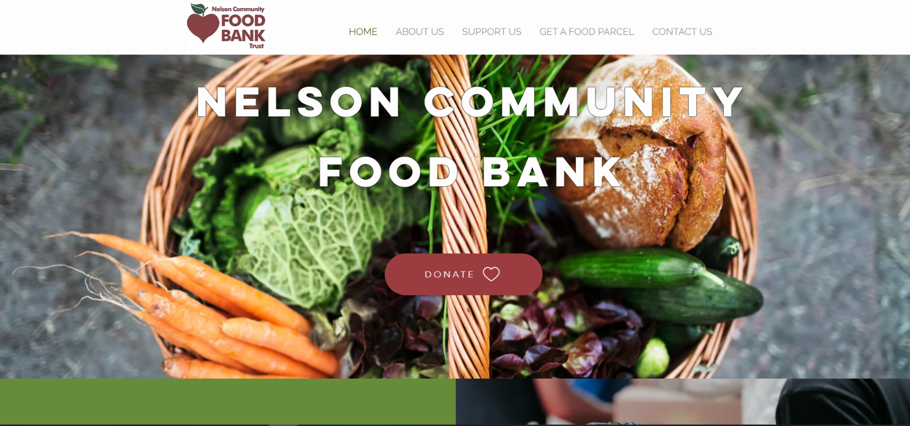

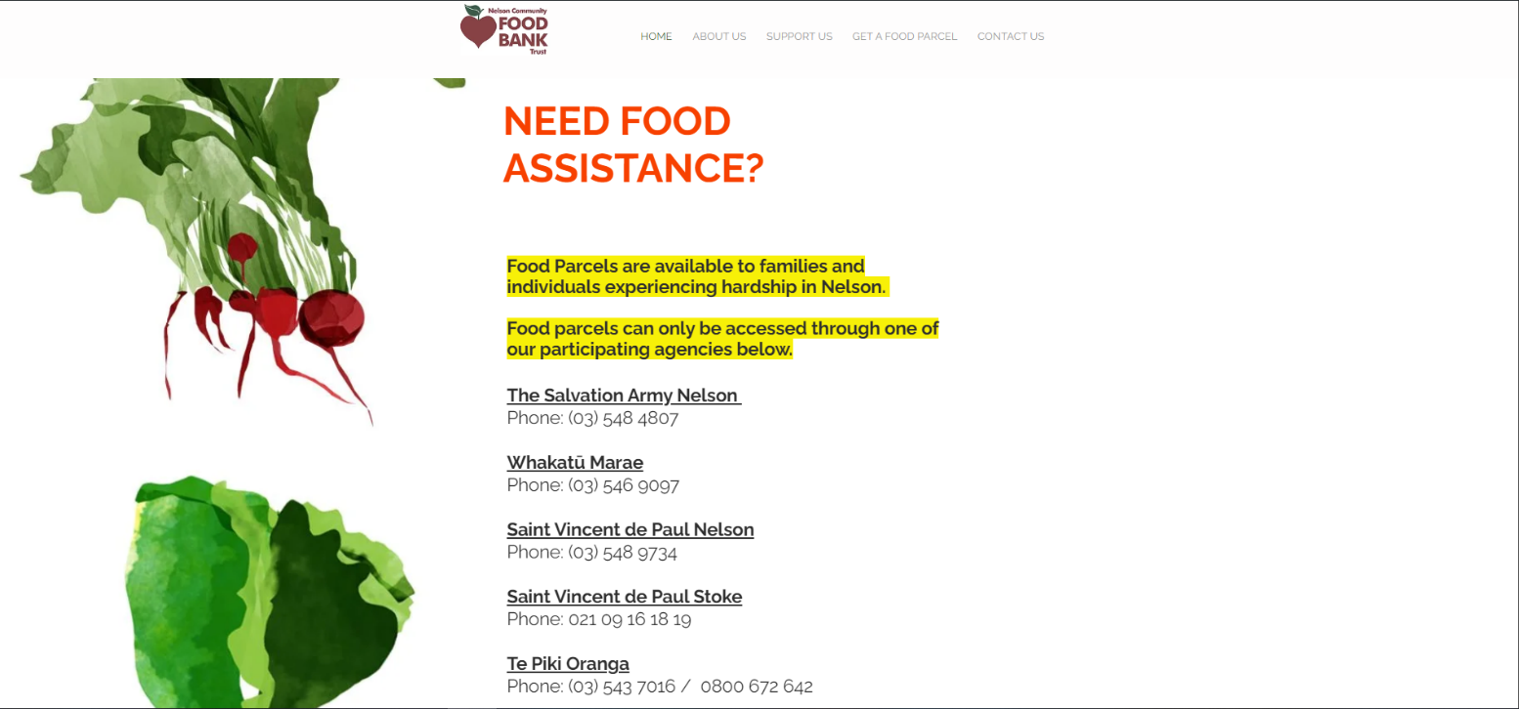

**Teddy NZ:**

The Teddy website’s design is minimal but done in a clean and simple way that makes it look nice and inviting for users. They use bright colors, clear bold text and relevant images regarding groceries. The user experience of the website is almost non-existent with all functionality and usage of the web app just refers to downloading their mobile application which is poor in my opinion.

Like the previous website, Teddy is a single webpage site with all information being fit into a single page but this time it is done in a tidy manner. The flow of the website is good with the initial landing page having a small but well written description of what, where and how of the application. Although they use a single webpage, most of the unimportant information is hidden behind tabs which helps clean the page up and stop the user from feeling overwhelmed at a first glance.

Their footer content is clean and well sorted with an easy-to-read font and having important links like customer support, social media links and company enquiries.

A large weakness of their website Is that a user cannot use their service without the mobile application, which limits their target audience and user engagement. A good idea would be to allow the service to be used from the website alongside the mobile application.

*Screenshots for reference below:*

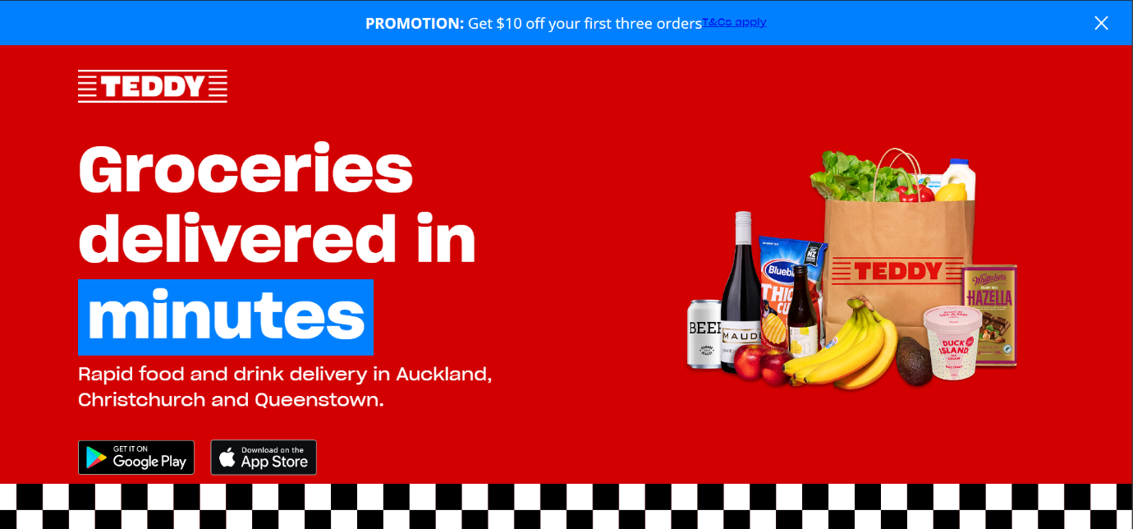

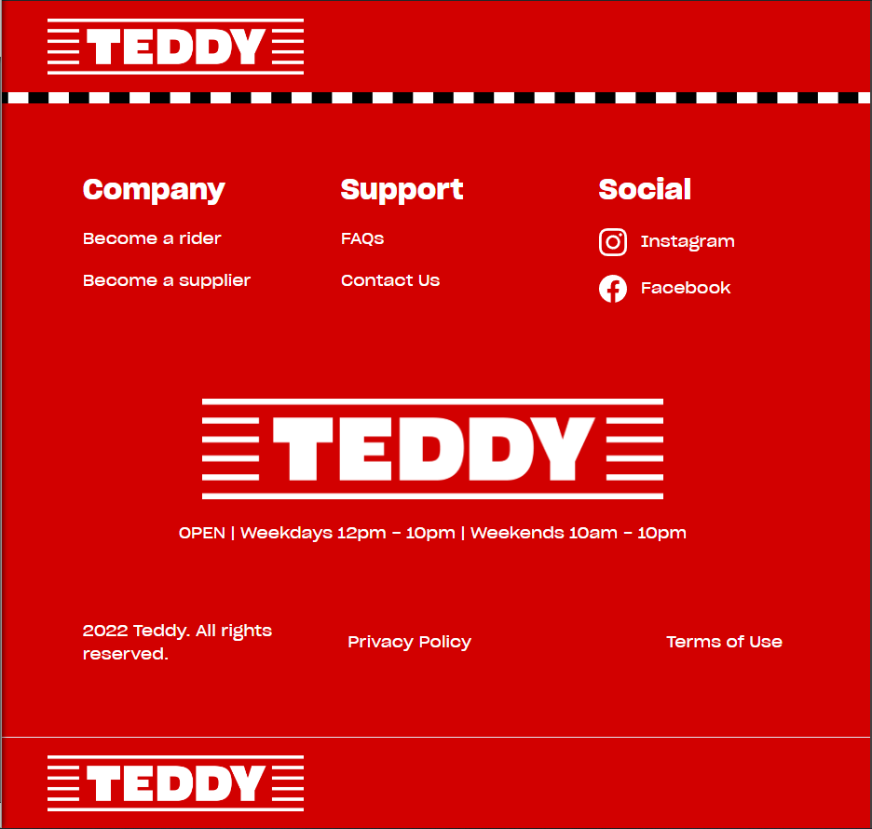

### Summary of Analysis

## Site Content

### Content and Functional Requirements

**Home Page:**

* **Welcome message:** Introduction to the Grow & Give charity service and a brief mission statement on its contribution to community members in need through donations
* **Overview of services:** Brief explanation of the how the platform works, including donation/beneficiary process
* **Buttons:**
  + Register as a Donor
  + Register as a Beneficiary
  + Learn more

**Registration/Login:**

* **Registration:**
  + Form for registering as a donor or beneficiary
  + Requires basic information in fields like Name, Email, Password, Business name? Contact information, Location, etc.
* **Login:**
  + Form for users to login to an existing account, either donor, beneficiary or administrator.
  + Once logged into an account, users can then access their profile management page, donation listings or logout of their account.

**Donor User Profile Page:**

* **Account information management:**
  + Users will have the option to update, change or remove any personal information linked to their account.
* **Donation Management:**
  + Dashboard where donors can list available donations, update exiting listing or remove any donation listing
  + Notifications or order section to inform the donor that a beneficiary has redeemed a voucher on one of their donations.

**Beneficiary User Profile Page:**

* **Account information management:**
  + Users will have the option to update, change or remove any personal information linked to their account.
* **Voucher Claim:**
  + Interface section for beneficiaries to acquire a code/voucher. Maybe view account balance?
  + Information on how vouchers work and how to redeem them

**Donation Listings Page:**

* **Browse available produce:**
  + Listings of the current available donations, with details such as item type, quantity, pickup location and status
  + Option to reserve? If so, instructions on where and when to pick up package

**About Us Page:**

* **Mission statement:** Charity’s mission and vision statement about the goals and purpose of the organization
* **Story:** Background of the organization and impact it aims to make in the community
* **Partners and Sponsors:** Information about the partnerships with local farms, businesses and community organizations

**Contact us Page:**

* **Contact form:** Simple form for general enquiries or volunteer sign ups
* **FAQs:** Frequently asked questions about the platform, donation process, token system and other aspects.

### Grouping and Labeling

**Main Navigation Content:**

* Home
* Register/Login
  + **ONCE LOGGED INTO AN ACCOUNT:**
    - Profile (Either Donor or Beneficiary)
    - Donation Listings
    - Log out
* About us
* Contact us
  + FAQs
  + Contact Form

**Footer Content:**

* Privacy Policy
* Terms and Conditions
* Social Media Links
* Basic contact Information

**Home Page Content:**

* Introduction and mission statement
* Brief Overview of how the platform works
* Navigation buttons for registration and about us page

**Registration / Login Content:**

* Form for registration and login for both donors and beneficiaries

**User Account Content:**

* Profile information management
* View existing donation listings

**Donor Content:**

* Donation management dashboard
* Notifications and alerts when a beneficiary redeem a voucher on their donation

**Beneficiary Content:**

* Voucher acquisition

**User support Content:**

* Contact form
* FAQs
* Other support information

## Site Structure

### Metaphors

**1. Organizational Metaphor: "Marketplace"**

* The site’s structure is similar to a marketplace where products/goods (fresh produce) are offered by donors and selected by beneficiaries
* Donors act as vendors or suppliers listing their available produce
* Beneficiaries act as customers browsing the available produce and using vouchers as currency to claim items.
* This metaphor shapes the layout and hierarchy, with the aim of clear listings, categories, and a checkout-like process

**2. Functional Metaphor: "Library System"**

* The website functions like a library system where items (produce) are catalogued, categorized, and checked out using vouchers
* The "catalogue" is the produce listing, organized by type, availability, quantity, and location.
* The "checkout process" involves beneficiaries claiming vouchers and requesting a produce package.
* This metaphor expresses searchability, filters, and managing accounts

**3. Visual Metaphor: "Produce Stall”**

* Visually, the site resembles a fruit/vege stall, showcasing the local freshly grown produce
* Earthy tones and related images could be used to represent fresh produce.
* Simple visual elements like baskets, crates, and open layouts create a welcoming feel for users.
* Icons and imagery (e.g., berry/fruit/vegetable images)

### Site Structure Listing

**Home**

│

├── **About Us**

│ ├── Our Goal

│ ├── Our Story

│ └── Partners and Sponsors

│

├── **Donate (Donor Section)**

│ ├── Register as a Donor

│ ├── Manage Donations

│ └── Notifications and Alerts

│

├── **Get Fresh Produce (Beneficiary Section)**

│ ├── Register as a Beneficiary

│ ├── Claim Vouchers

│ └── Browse Available Produce

│

├── **Login/Profile Page**

│ ├── Profile Management

│

├── **Contact Us**

│ ├── Contact Form

│ └── FAQs

│

└── **Footer**

├── Privacy Policy

├── Terms and Conditions

└── Social Media Links

### Architectural Blueprint

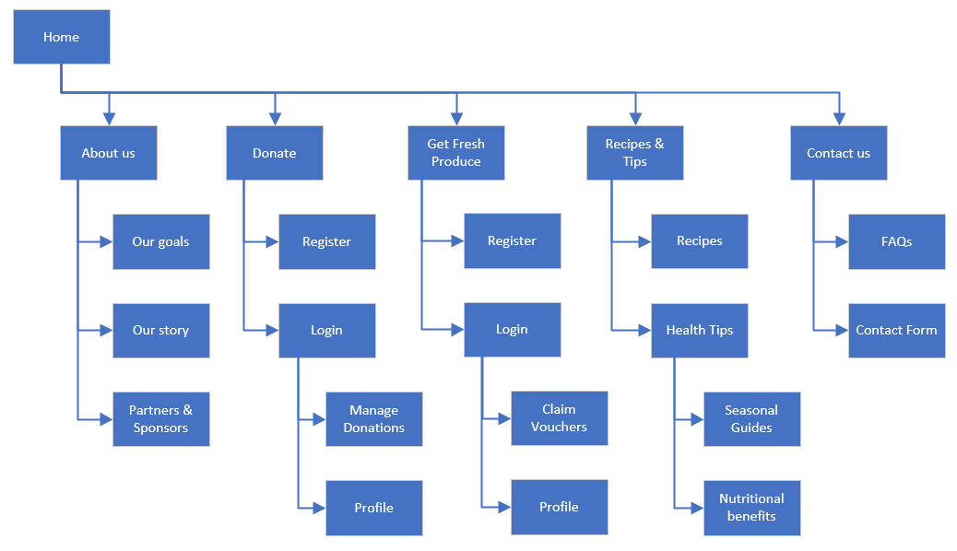

### Define Navigation

**Global Navigation:**

The global navigation appears at the top of every page and includes the following links:

* **Home**
* **About Us**
* **Donate (Donor Section)**
* **Get Fresh Produce (Beneficiary Section)**
* **Recipes & Tips**
* **Events & Community**
* **Contact Us**
* The global navigation is consistent across all pages and uses a simple drop-down menu for any section with subpages (Recipes and Tips for example)

**Local Navigation:**

1. The local navigation appears within specific sections and includes links to relevant subsections but in this current iteration of the charity website, I don’t plan on incorporating any local navigation and only rely on the global navigation and possibly some breadcrumbing to help users see where they are within the site’s hierarchy (e.g., Home > Get Fresh Produce > Browse Available Produce).

**Footer Navigation:**

* The footer contains links to important informational pages like Privacy Policy, Terms and Conditions, and social media channels. It also includes a sign-up option for the newsletter.

## Visual Design

### Wireframes

#### Home Page

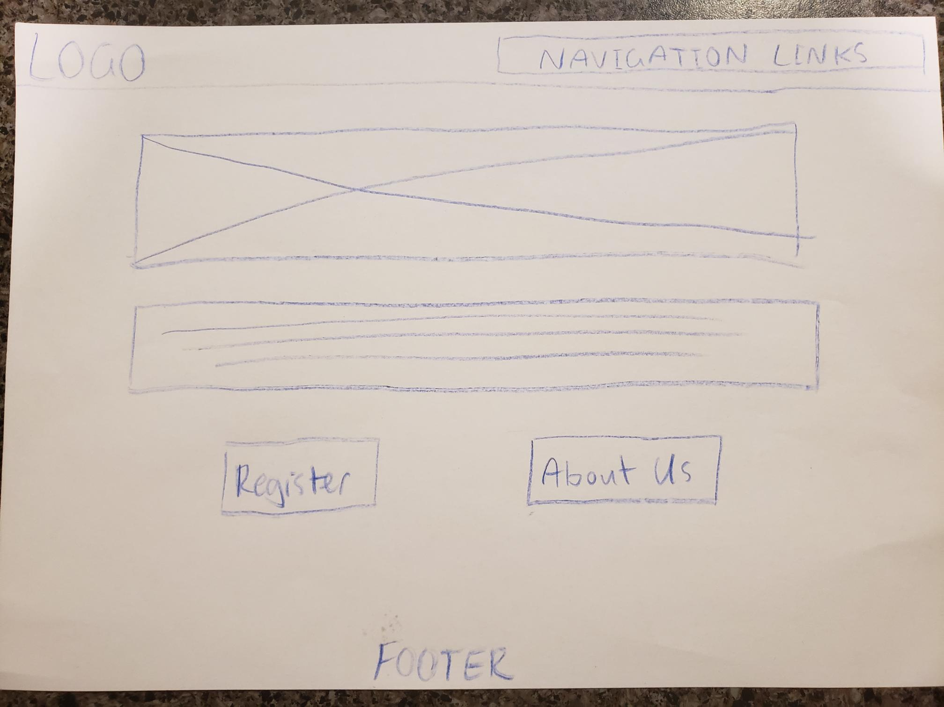

#### About Us Page

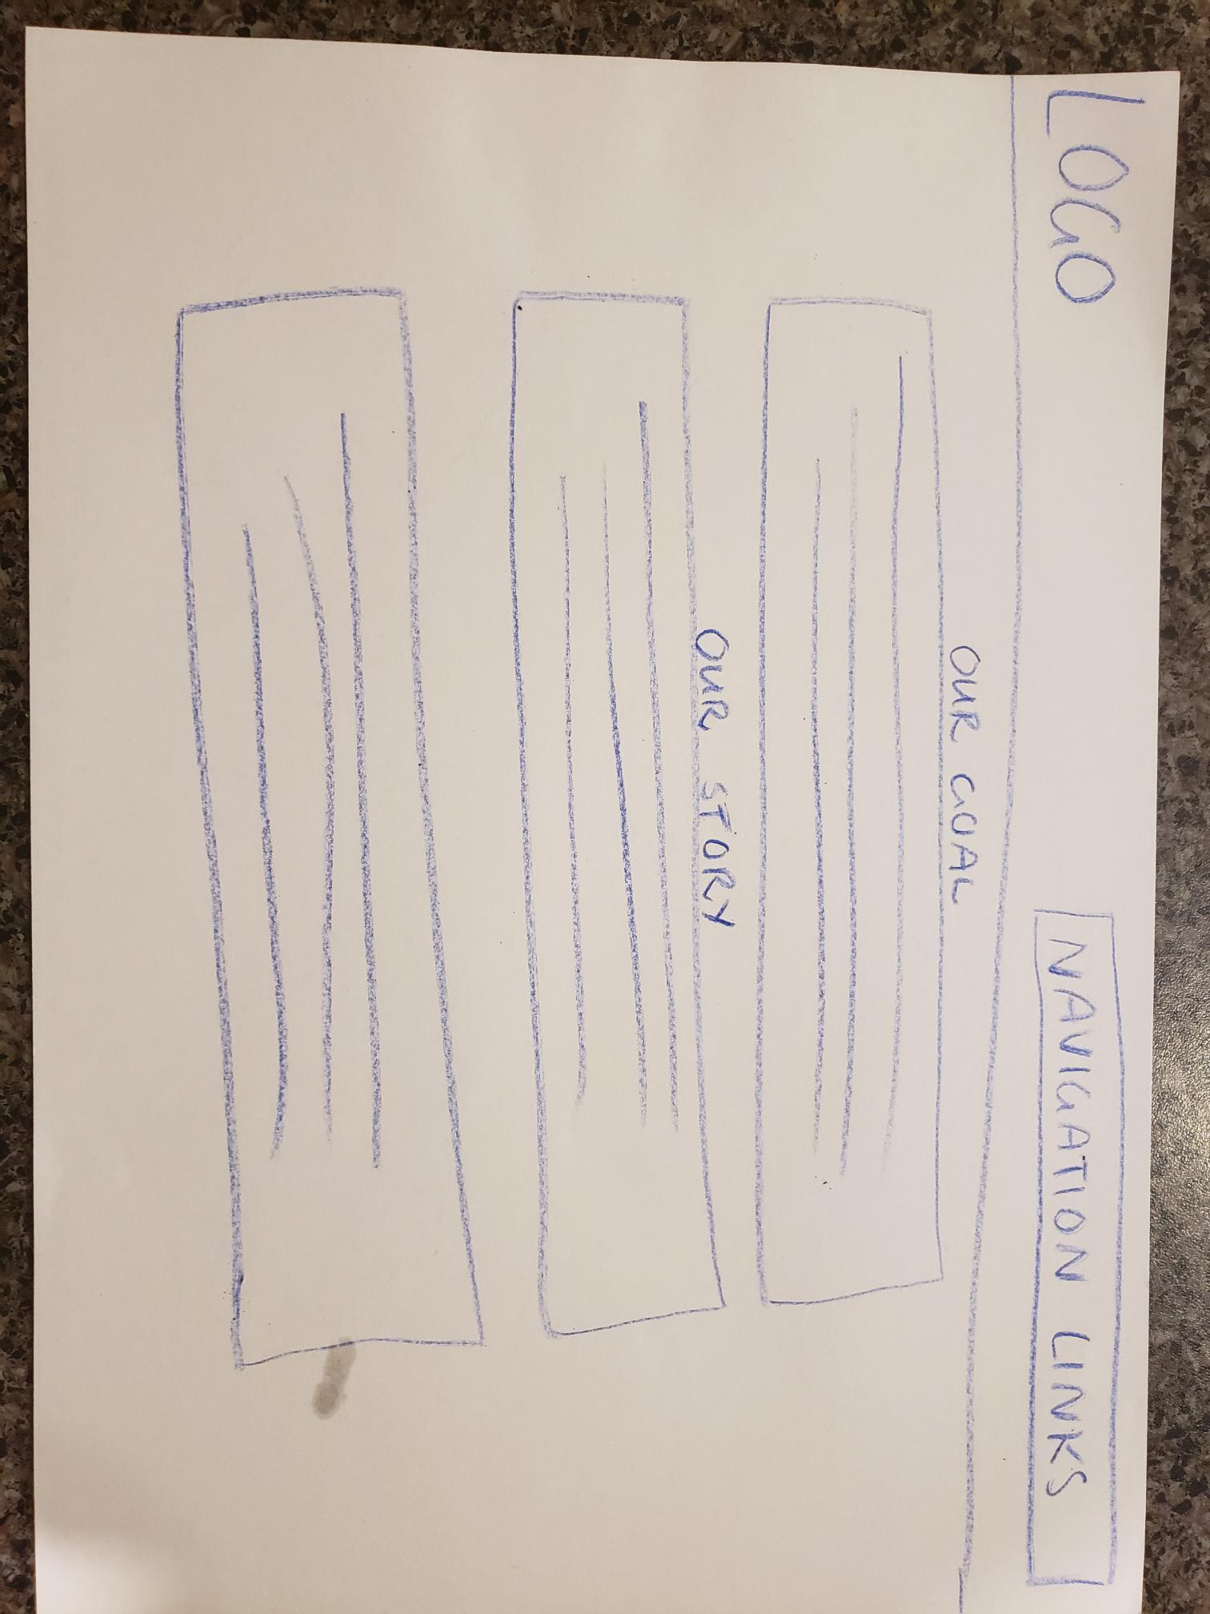

#### Contact Us Page

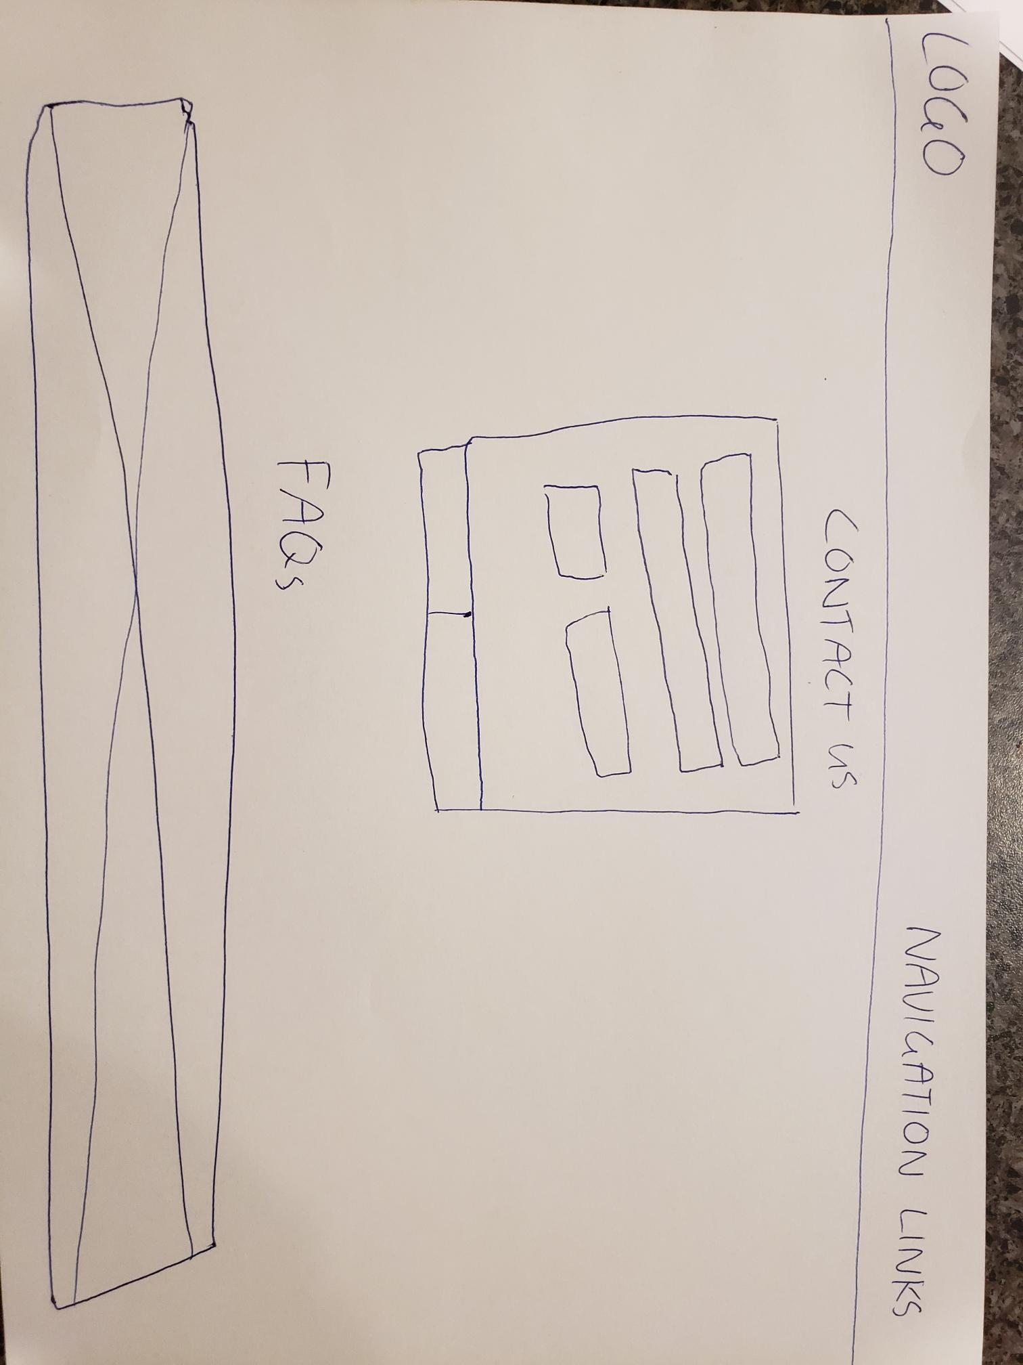

#### Register/Login Page

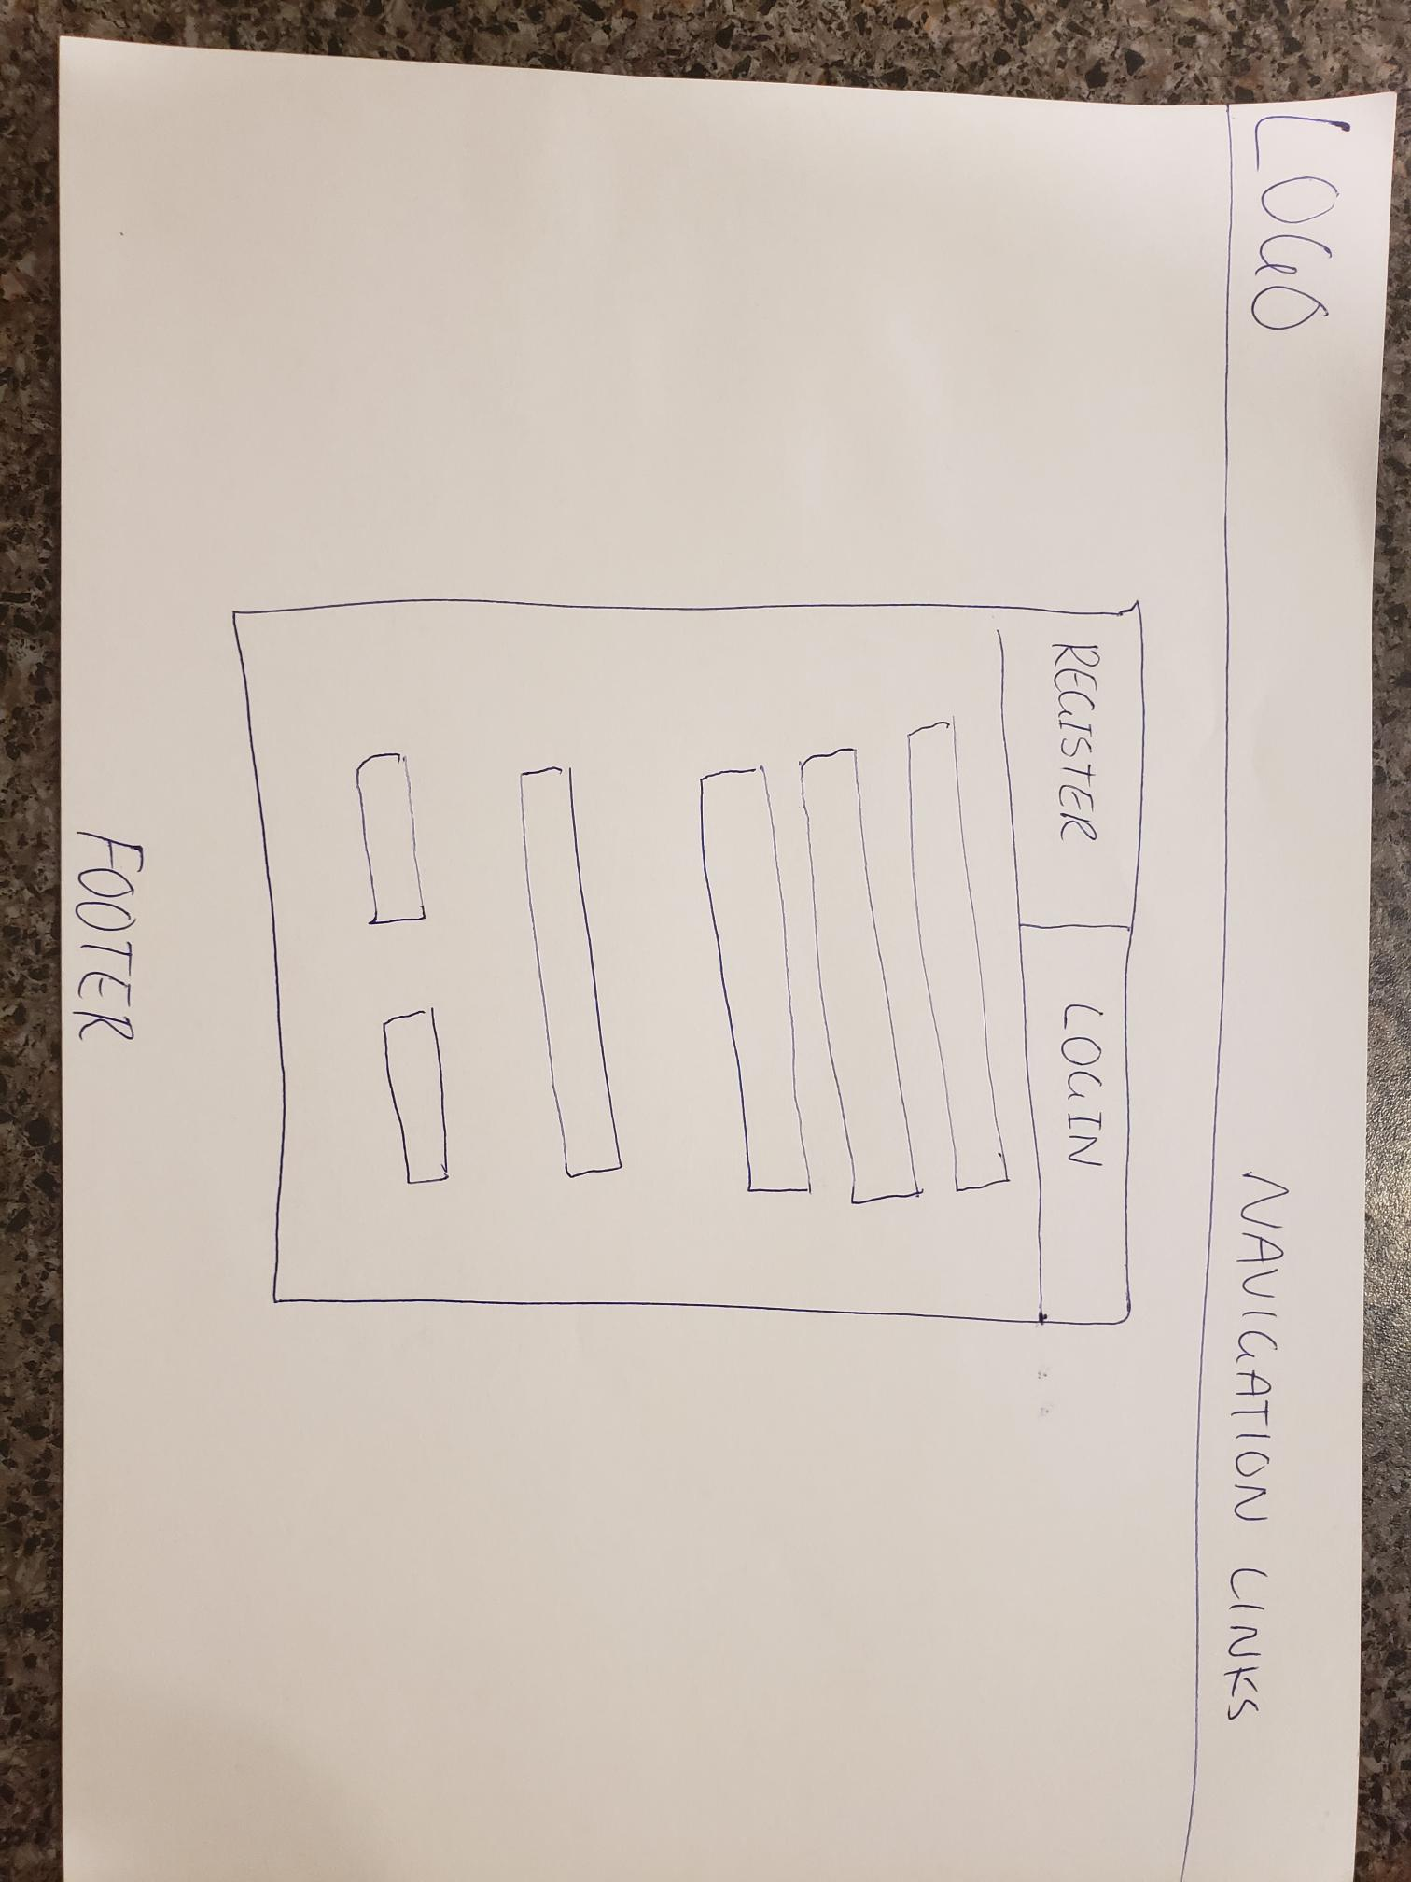

#### Profile Page

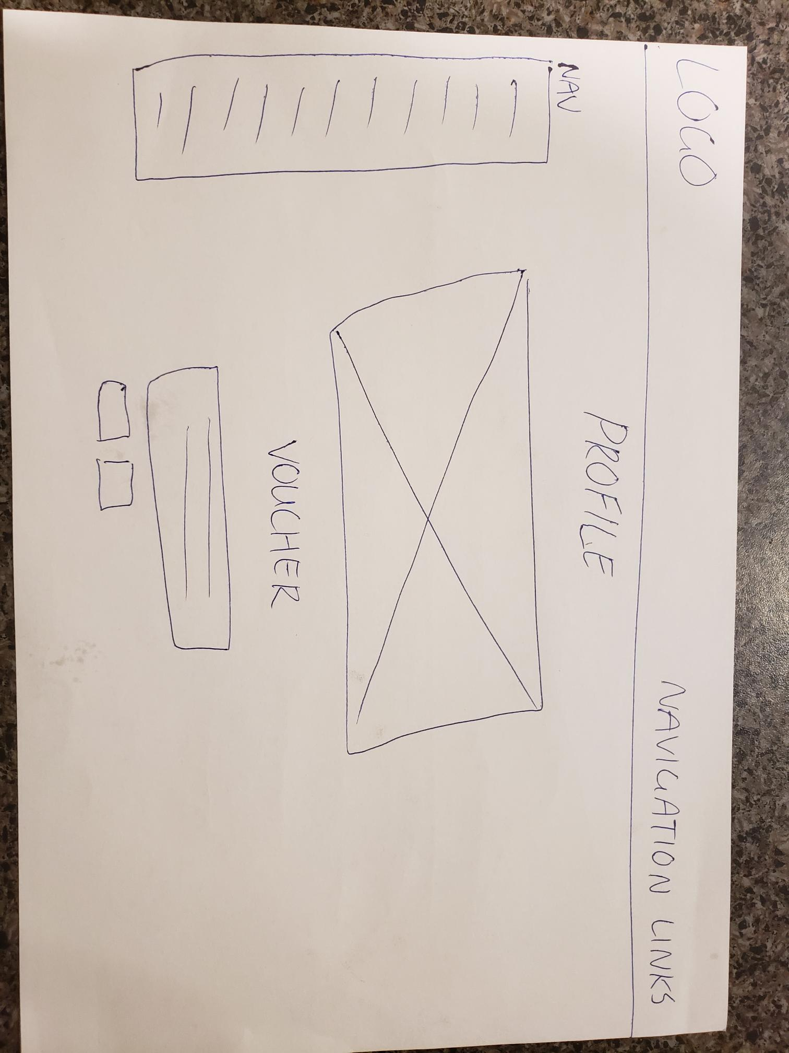

#### Donation Catalogue Page

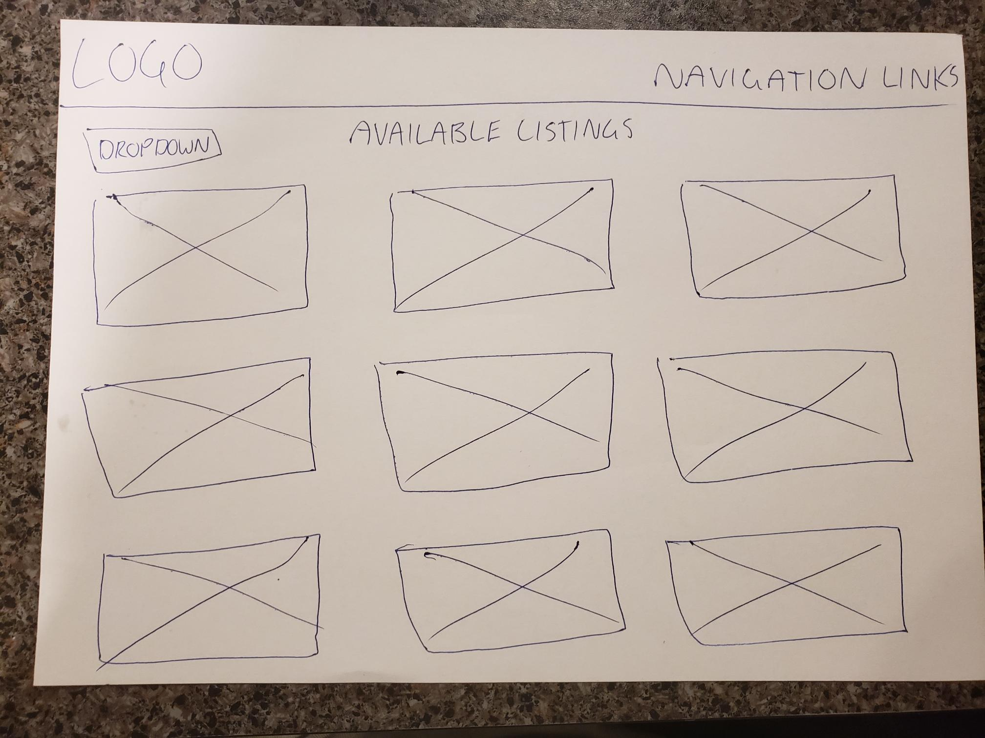

### Mockups

#### Home page

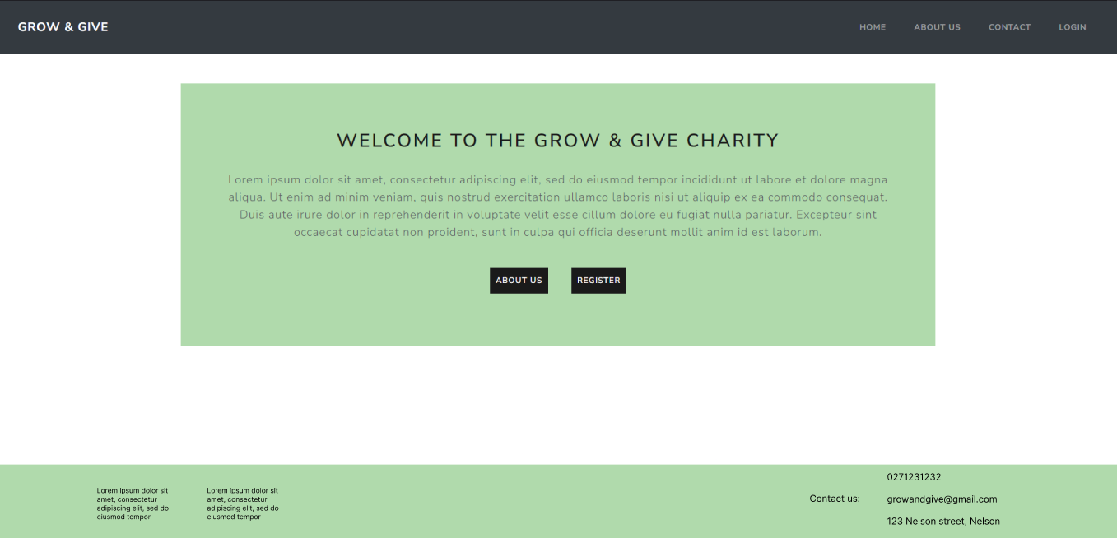

#### About us Page

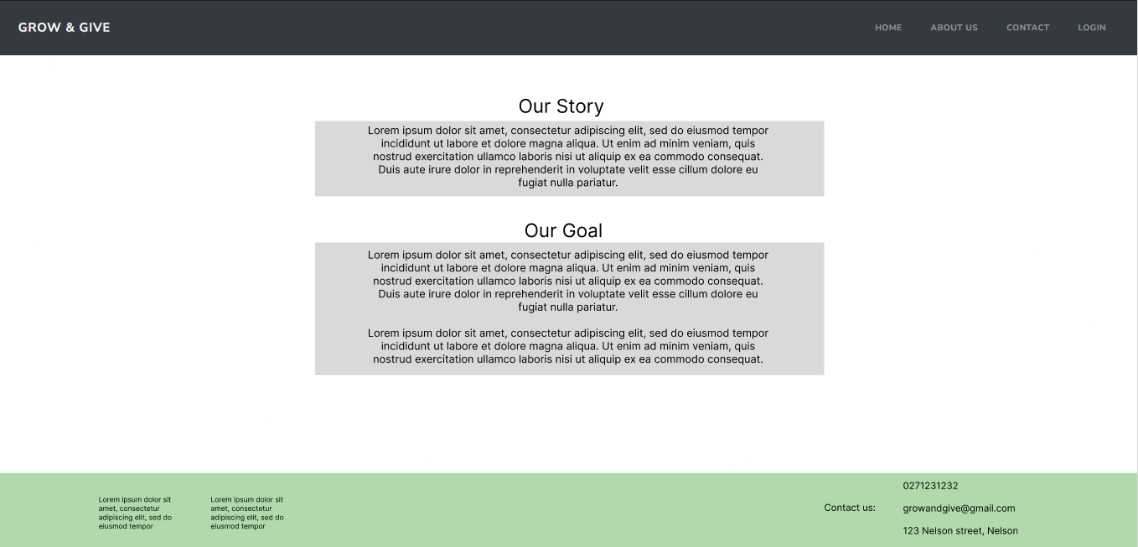

#### Contact Page

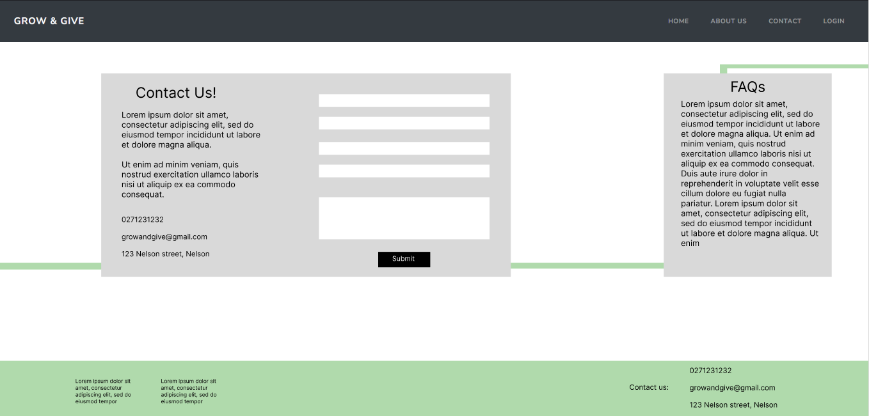

#### Register Page

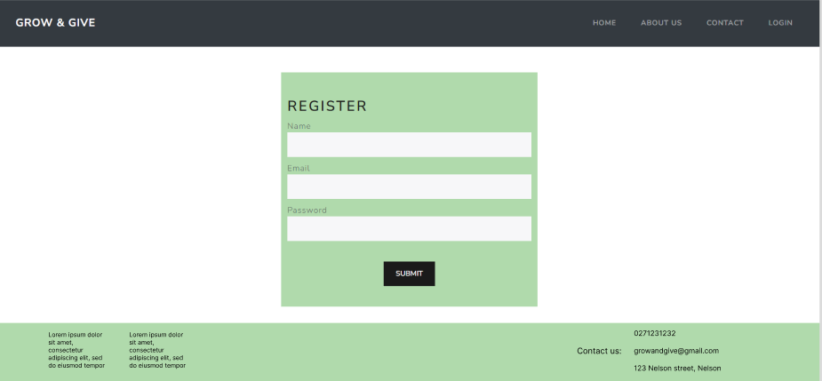

#### Login Page

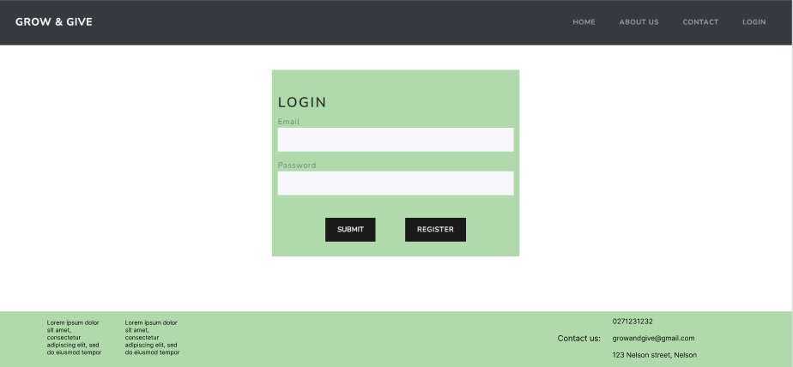

#### Profile Page (Beneficiary)

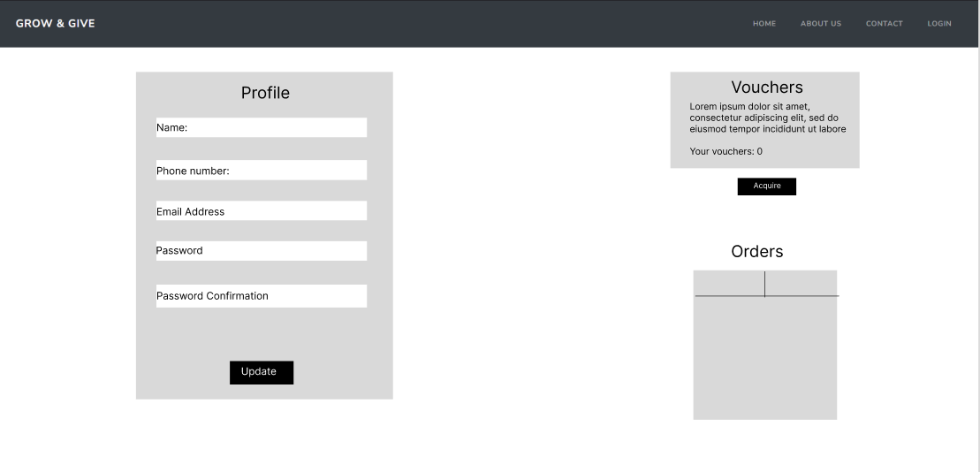

#### Profile Page (Donator)

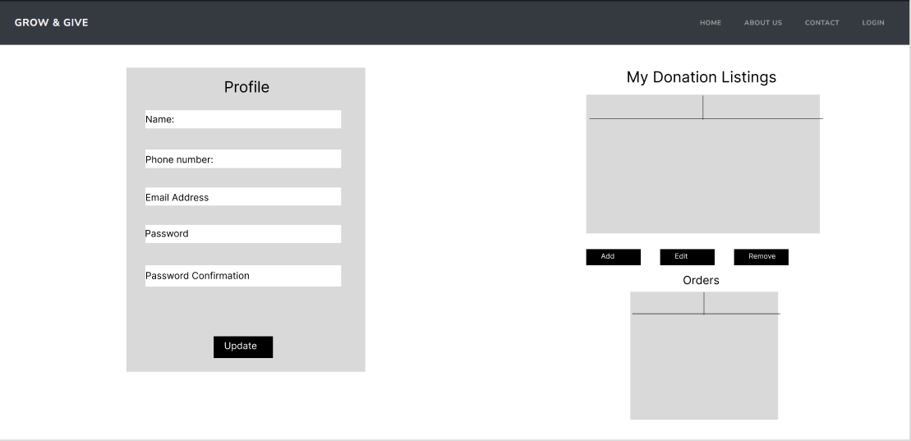

#### Donation Listing Catalogue

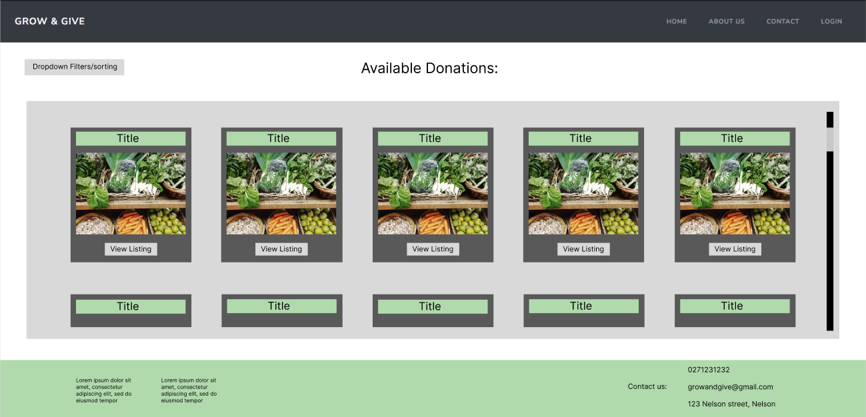

## User Stories

The list of user stories discussed below came about from the scenarios previously mentioned in the ‘Define the user experience’ section of this document. In those scenarios, we discovered some high level functionality that should be implemented into the web application. The user stories aim to flesh out those features and further define what functionality is needed to be developed to satisfy user needs. Understanding what features are needed also helps with the development of the project management kanban board and what CRUD APIs are required for each of those features.

* **Donator Registration**

As a local farmer,

I want to register a donor account and verify my identity,

So that I can give fresh produce to community members in need while ensuring trust in the service

* **Beneficiary Registration**

As a single mother,

I want to register a beneficiary account and verify my eligibility,

So that I can receive fresh produce packages for my family

* **Donor Login**

As a donator for the Grow & Give charity,

I want to login to my account,

So that I can offer my fresh produce

* **Beneficiary Login**

As a beneficiary for the Grow & Give charity,

I want to login to my account,

So that I can access their services

* **Account management**

As a registered user (donor or beneficiary)

I want to manage any saved profile details and personal information,

So that I can keep my account information current or remove for security reasons.

* **Donation creation**

As a donator,

I want to create new donation listings,

So that beneficiaries can see what I have to offer.

* **Donation management**

As a registered donor,

I want to manage my existing donations,

So that I can change or update any relevant information like availability or quantity.

* **Search donation listings**

As a beneficiary,

I want to search for available produce donations with possible filters,

So that I can find relevant donations that are convenient for me to collect

* **Voucher acquisition**

As a beneficiary,

I want to acquire vouchers and view the number of vouchers I have left to obtain,

So that I can apply for produce packages.

* **Limit voucher acquisition per month**

As a beneficiary,

I want to see the number of vouchers I have remaining for the month,

So that I can manage my usage efficiently

* **Use vouchers**

As a beneficiary

I want to redeem my vouchers on a specific available listing I like

So my order can be processed

* **Accept order**

As a donator

I want to accept redeemed vouchers

So that I can give my listed produce to those who have ordered a package.

* **View Order Status (For beneficiary)**

As a beneficiary

I want to view the status of my orders after redeeming a voucher,

So that I know when and where to pick up the package

* **Contact**

As a user of the website,

I want to send a message or enquiry to the charity administrators,

For support or further information about the service.

### CRUD Analysis

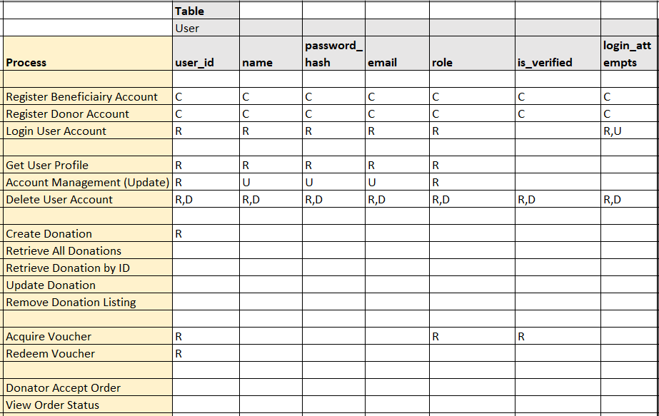

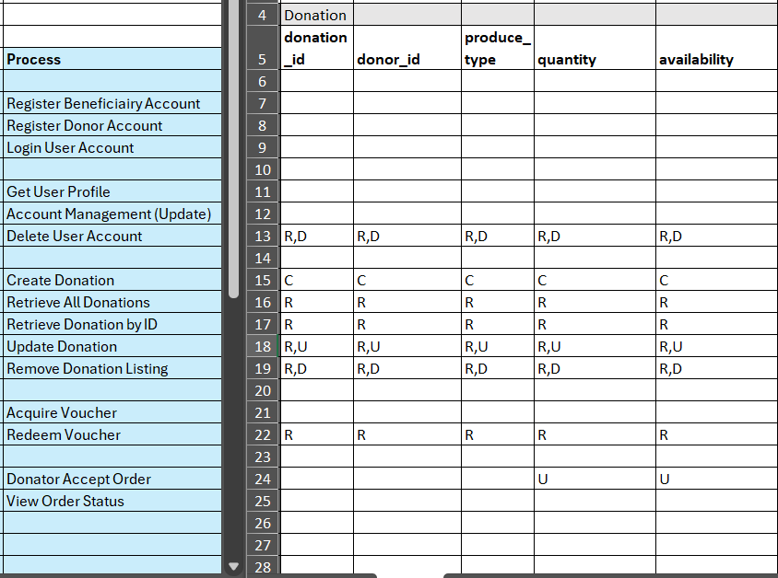

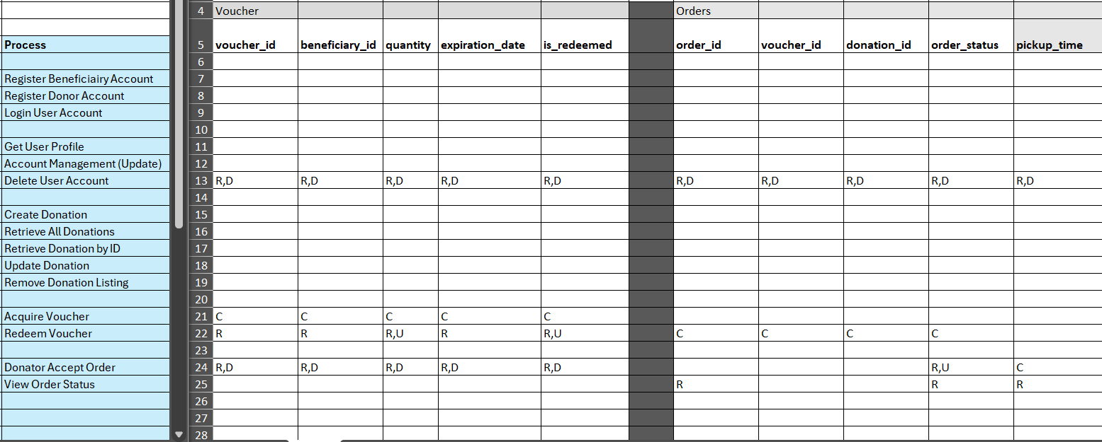

### Backlog List

Each User Story has been grouped into an EPIC which then gets broken down into individual features or tasks that are needing to be completed.

* Donator Registration
* Beneficiary Registration
* User Account Login
* Profile Management
* Create Donation
* Manage Donations
* Accept Order (From Beneficiary)
* Voucher Acquisition
* Voucher Limiting
* Voucher Redeeming
* Donation Listing Search
* Order Status Display
* Customer Support

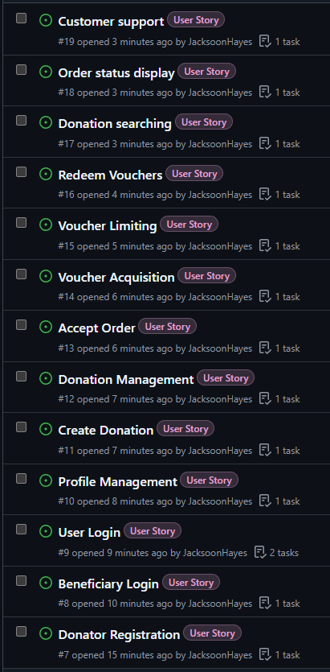

**GitHub Project:**

<https://github.com/users/JacksoonHayes/projects/5>

# Evaluate – Milestone Two

## Purpose of Web Frameworks

A web framework is a piece of software that offers a way to facilitate the development and running of web applications, websites, as well as to develop APIs (Technologies, 2024). Web frameworks can become very comprehensive in its scope but also offer developers a number of benefits ranging from offering pre-written code, tools and templates for managing complexities of web development like routing, authentication and database connections. This makes building applications faster and more efficiently due to less code needing to be written and focusing on constructing reusable components or code that can easily be used throughout the application (Sheldon, 2023).

Frameworks have now become widely used in commercial web development, adhering to industry standards and have grown strong developer communities that help to optimize the code and reduce errors further leading to better performance, reliability and easier maintenance. In summary, web frameworks help to make web application development faster, simplify any debugging needs and increase the app’s reliability with many frameworks being open source and free to use which can greatly reduce development costs.

### Common Web Framework Features

Many of today’s common web frameworks depend (but aren’t limited to) the MVC (Model, View, Controller) software architecture/design with Controller receiving user input through an interface and manipulating or updating the Model which then tells the View which display or interface should be updated (Technologies, 2024). A reason this pattern is preferred within web frameworks is in its design that separates the applications logic from the user interface and forms which creates a clean and maintainable code base for developers to work with.

Additionally, web frameworks commonly have the following features:

* **Reusable Components**
  + Components allow developers to create custom, reusable elements for their web application which are broken down into smaller modules that are easier to maintain.
* **URL Routing**
  + Manages how different web pages or URLs are linked to specific functions or views of user interfaces. Defines what content is being loaded when the user visits /home or /profile for example.
* **Templates**
  + Similar to the reusable components feature, templates allow for content generation that provides a structured design for pages or components. An example of this can be seen within component generation command used in Angular which will create all the files for a new component that developers can tailor to what is specifically needed (nav bar, footer, home page, etc.). Additionally to component generation, frameworks often provide complete source folder structures inside the workspace when installing a framework.
* **Database Connection**
  + Provides tools to easily connect and interact with databases including all CRUD operations (create, read, update, delete). Commonly used is the NoSQL document driven MongoDB but can easily be connected to any others, SQL or not.
* **Security**
  + Many frameworks like React, Angular or Vue include built in features for preventing common security risks like SQL injection, cross site scripting and request forgery.
* **Validation**
  + Ensures that data being submitted by users meets predefined criteria before being accepted by the framework. An example of this is within forms (login, registration, contact), where the user needs to input certain text like an email address.

Other smaller but common features of frameworks include the tools to build and interact with RESTful APIs in the front-end, authentication/authorization support to manage user logins, and middleware for processing requests/responses with is often tied into the authentication or for logging.

### Features Relevant to the Scenario

In terms of the Grow & Give charity website, the framework features mentioned above that are particularly relevant include routing, database integration, form handling, authentication/authorization, API creating, security and validation, but aren’t limited to these. The reasoning behind indicating these features as relevant to the charity website is:

* **Reusable components:**
  + The use and structure around reusable components will be an important aspect of the donation listing catalogue, where only a small amount of code will be needed to create a listing card and then can be reused throughout many different listings. Other components that this will benefit from include the navigation bar, footer and profile pages.
* **Routing:** 
  + The website, as discussed previously in this document, will have various different routes such as /register /login /dashboard /profile /home, etc. With each route being responsible for different user actions and views being displayed. The website will also make use of the dynamic routing feature included in many web frameworks, allowing for URL parameters such as /users/:id or donation/:id to handle user specific data and/or actions.
* **Database Connection:**
  + The website will need to connect to a database or some sort, probably MongoDB to store user account data (donors and beneficiaries), donation listings, vouchers and user orders/order history.
* **Form Handling:**
  + Will be used to simplify the processing of form based features/components like the user login, registration, contact form, donation listing creating and potentially the voucher acquisition by beneficiaries.
* **Authorization/Authentication:**
  + While frameworks don’t necessarily come with built in features for authorization, many web frameworks support the implementation of JSON web tokens (JWT) through Express.js/Node.js. JWTs will be issued, validated and used to authenticate and authorize users for secure access to pages such as a user’s profile page and what content is shown to them. It could also make sure that vouchers belong to specific verified beneficiaries.
* **Templating:**
  + Many frameworks come with their own way to generate components which include templates for efficient and quick development of new features that follow a pre-included structure. This will be beneficial to use within the website to keep a clean and structured workspace but also for faster development of components and features.

Given the requirements identified previously within this document and during the analysis/design phase of the software development lifecycle, a web framework like MERN (MongoDB, Express.js, React, Node.js) or MEAN (MongoDB, Express.js, Angular, Node.js) could be well suited for this project. These two frameworks are very popular within the current industry and offer scalable solutions for handling content and user management while displaying responsive and engaging user interface. These web stacks include a simple serverless database management tool in MongoDB Atlas and allow for secure user authentication/authorization with the implementation of JWT. While the project is not limited to these two web stacks, proving a comparison between them will be simplified considerably since they use the same backend technology with the difference being the way React and Angular interact with it.

## Emerging Web Technologies

### Describe and Identify an Emerging Web Technology

An emerging web technology is a new software innovation that has potential to impact the way websites or web applications are developed, delivered or interacted with by its users. These emerging web technologies are intended to meet the constantly evolving needs of both developers and users, often changing how services are designed which can create a more advanced, accessible and user-friendly web application or website (Kundariya, 2024).

Some of the current and common emerging web technologies include:

* **Implementing AI or LLM**
  + APIs for integrating AI or Large Language Models (LLM) can be used for chatbots or generating personalized content. Tools like ChatGPT and Llama AI have become incredibly popular and have been used more and more by developers to help with content creation or to replace traditional customer support methods (Murphy, 2024).
* **Serverless computing**
  + Serverless computing runs on cloud technology which lets users/developers to run code for any type of application or service without requiring administration, managing or scaling servers when needed. As of 2022 the market for serverless architecture was valued at $36.8 Billion USD (Murphy, 2024), and will only continue to grow as more products look into serverless functions like file backups or exporting objects.
* **Progressive Web Apps (PWA)**
  + Progressive Web App’s is an app that is built using web technologies but provides the user experience like a native or platform specific application. (*Progressive Web Apps | MDN*, 2023). PWA’s use the best features of both to provide offline capabilities, push notifications and faster performance times without the need to install the entire app with existing large apps like Google maps and Uber using PWAs to allow its operation even when offline. They can run on multiple platforms and devices from a single codebase and like native apps, can be installed and operated while offline or in the background.
* **WebAssembly (WASM)**
  + WebAssembly lets developers run higher performance, complied code in browsers which greatly improves the load times and is usually written in languages like C++, C#, Rust, etc. Currently and commonly, JavaScript is used to develop websites and web apps and is compiled as needed by the browser engine which causes some delay in execution as opposed to being compiled ahead of time and almost to a machine-level, like C++, C# and Rust. Typically, a program cannot be written in these languages and run inside a browser as it is very limited in what it can run, which is where WASM comes in to allow code in these languages to be written and then compiled to WebAssembly, meaning the browser can read and run the pre-compiled code (*WebAssembly | MDN*, 2024).

For the website and charity project, Grow & Give, the emerging web technology that I will be selecting and plan on implementing is the use of large language models (LLM) through an API that will provide users a means of generating personalized content in the form of recipes and/or health tips.

**Relevance and impact on internet services.**

An emerging web technology which has significant relevance to internet services today large language models or AI, like OpenAI’s ChatGPT or other AI chat systems (Gemini, Llama, Perplexity, etc.) with their integration into applications through APIs. Recently in the last few years, these models have gained a lot of traction due to their rapidly evolving capabilities to understand and generate human like responses to user inputs. Many businesses in todays age can be seen implementing LLMs across multiple different areas such as chatbots, customer support, assistants and content generation (Langley, 2024).

One interesting concept that is possible thanks to application of LLMs in web and internet services is the shift to an on demand web model where data, information or even entire websites are generated in real time, tailored specifically to user needs rather than the always available information model used currently (Langley, 2024). When a user initiates a search or uses a browser, instead of retrieving data from a database or website, the LLM would generate only the necessary information in real time, generating a personalized summary from multiple sources or creating new content that better aligns with the users input. This means that websites, articles or media content would not longer be stored on serves in the traditional manner but generated as needed.

As LLMs become more advanced, their ability to perform tasks that would have required human workers will expand and can lead to changes in the job market. This includes areas such as automation of work that requires writing, analyzing or editing reports, articles or even code and as these models improve, they could very well automate jobs like researchers, journalists, data analysts, customer support and more.

While there are many positives in the evolution of large language models and generative AI, it is also essential to consider the ethical risks and bias once implemented into an application or service. In terms of the ethical considerations, establishing clear guidelines and boundaries could help to set standards to ensure that AI generated content is clearly labeled and not misused to spread false or misleading information. There is also risk for bias and fairness around the LLMs inadvertently using stereotypes or marginalizing certain groups by generating content based on the training data used which could lead to discrimination in various work fields. Because of this, addressing potential bias will require constant efforts and monitoring to adjust the LLMs so these risks are mitigated.

### Selection and Implementation Analysis

I selected the large language model API, specifically ChatGPT, as the emerging web technology to implement an interactive aspect into the website and give it more depth so it is not just another e-commerce style web application. The rational for selecting the LLM as the emerging technology comes from its ability to provide additional functionality and value services to beneficiaries who might need quick and accessible information on how to use the fresh produce donated to them. This addition aligns perfectly with the missions and goal of the charity website, which is to promote healthy and nutritious eating with a minimal cost through fresh produce donations.

I began by researching different emerging web technologies in the search for one that was not only fitting for the website but also relevant enough that it could be implemented and still meet the requirements. There was a toss up between serverless computing and LLMs but felt like I could add more functionality to a rather simple web application through the incorporation of a generative AI feature. I then began researching LLM APIs further and looked into models like Llama installed locally and Google Gemini as both options are free to use and Llama even being open source. Despite both of these options being more than suitable for the website, I decided to select the ChatGPT API for implementation for no specific reasons and while it isn’t free to use, the cost is to use is very minimal and done per request.

The ChatGPT API allows developers to send user inputs such as questions about recipes or health tips and receive a tailored response that is informative. ChatGPT also allows for fine tuning such as the ability to implement specific ‘GPTs’, for example one that is more knowledgeable around recipes, health tips and nutrition.

In terms of its implementation into the project, the OpenAI SDK is needed to be installed and imported into the workspace, while the ChatGPT API is integrated into the existing backend code and can be interacted with through HTTP requests. With both tech stacks currently being compared (MERN/MEAN) offering good support for RESTful APIs the process of embedding this feature should be easy and seamless once finished. All of this will be linked to a simple form on the frontend (React or Angular) for users to type in their questions and then display the LLM response in real time.

### Impact on Internet Users

The implementation of large language model APIs like ChatGPT into web applications/services can have a great impact on how users interact with it. Firstly there are positive impacts like improvements to user experience by providing personalized advice directly through the website which users will feel more engaged and supported when receiving a food package since beneficiaries might not know how to prepare or use the produce they get. The integration of a LLM will offer them instant ideas and tips and overall improving the user experience. While there are many positives of LLM implementation, there is also the impact it can have on broader internet services such as the mainstream use of AI causing users to get frustrated or look to alternatives and can be seen in companies like Facebook and many more that have entirely replaced their customer service with an AI chatbot or something similar. While these companies are trying to save money by making their customer support call center redundant, having no human customer service is bad for consumers of a service as it diminishes the customers trust and leads them to go elsewhere if they can (Stewart, 2023).

Outside of the customer service area, LLMs have been rapidly taking over image generation which seems to have mixed opinions. This could be due to the slow, gradual replacement of human made art, images or photography and many people taking advantage of the free to use, non-copyrighted AI image generation for profit through selling these generated images as their own or leading internet users on through fake, but life like images. While it can be amazing to see the realistic and detailed AI images, there is also the frustration that comes with these highly accessible tools that imitate the work of skilled humans.

In terms of the Grow & Give charity website, the personalized nature of LLMs responses, adds to the website and helps to cater to user needs more directly and efficiently for example, a user asking for a recipe for the produce ingredients they received like carrots and potatoes can quickly support those who want the service provided by the Grow & Give charity but don’t necessarily have the skills or knowledge to benefit fully.

Additionally to this, incorporating a LLM into the proposed web application should increase its accessibility and support by allowing users of any technological background or level of knowledge to access information easily. Instead of manually searching for recipes or health tips, they can simply ask in their natural language and receive instantaneous responses. This makes the website accessible to a wider audience even those who are not familiar with or comfortable with technology. Although its not the intended reasons for integrating the LLM, it could reduce the need for any human customer/user support for answering common questions related to food donations, recipes and health. The model could handle any basic queries which essentially replaces the need for human staff to operate customer service and allows them to focus on more complex or important tasks.

In summary, the integration of large language models into the charity website will mostly have a positive impact on its users in areas such as improved user experience, convenience, better accessibility and user engagement, while also allowing for future scaling and continuous improvement through customer service automation and easily scaling to an increase in the number of users and LLM requests.

## Web Framework Evaluation and Comparison

The two web frameworks that I will be evaluating and comparing are React (MERN) and Angular (MEAN). These two will be used to build a prototype application that allows users (donors and beneficiaries) to register an account, login to their account and administer their account details with extra functionality like the integration of JWT to manage user authentication and storage/retrieval of data in a database with this being verified by displaying a list of the user’s details.

The comparison will involve a detailed look at how these two frameworks operate and connect to the rest of the full stack application. With both of these web stacks using the same server-side and back-end technologies (MongoDB, Express.js and Node.js), the comparison will essentially be analyzing how these frameworks interact with and connect to everything else to make a functioning and smooth web application. Because of this and to make development easier, both web stacks are using the exact same backend/server to run the application. This means that the routes and models used in the database are the same but also makes conducting a comparison more simple.

### 1. Registration / Login

This section allows users (charity donors and beneficiaries) to register, log in and manage their own accounts. Users are able to administer their accounts in the way of password management and seeing information related to the account on the profile page. Authentication is handled through JWT (JSON web tokens) which is used to transfer the state between client and server, ensuring users remain logged in securely and denying access to user profiles without a valid JWT to protect routes that require authentication.

The prototype application is primarily to demonstrate the registration/login process and applying self-administration to their own account, all while authenticated and authorized with JWT. The final application will see charity donors able to register and manage their products and/or services, while beneficiaries can acquire and redeem vouchers for these products/services if accepted by the owner of the donation listing.

**Framework 1**: MERN

1. **Backend:**
   * **User Model:** The User schema (userModel.js) is used to define fields such as name, email address, password, vouchers available and placeholders for user role type. Mongoose is used to define the structure for the database and takes in these fields depending on what is entered in the registration form. There is a default value set to the vouchers for each new user receiving 10.

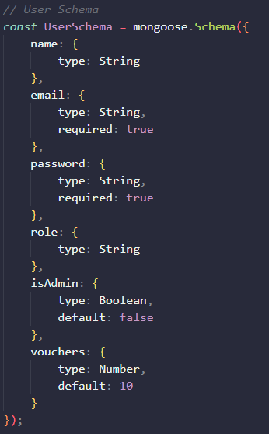

* + **Register route:** In the register route, the controller file (userController.js) checks if the email is already registered and belongs to an account in the database. If not, it hashes the password using ‘bcrypt’, creates a new user entry/document and saves it within the MongoDB database.

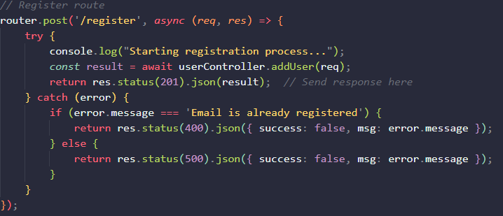

* + **Authentication:** JWT is used in the authenticate route, with the controller file first verifying the user’s email and password. If valid, it will generate a JWT using the ‘jsonwebtoken’ import and the secret stored in the .env file. The generated JWT has an expiration time of 6 hours (21600 seconds) which is set in the userRoute file.

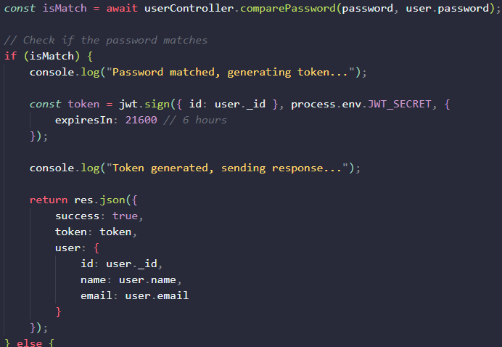

* + **Protected routes:** In the prototype application, routes like /profile, /update and /redeem-token use ‘*passport.authenticate(‘jwt’, { session: false })*’, as shown in the screenshot to ensure only authenticated users can access these endpoints. The update route then allows a logged in user to update their password but could be changed to allow for changes to any account specific information. This authentication route uses the passport library and can then be applied to any routes/endpoints to ensure proper access levels to page content.

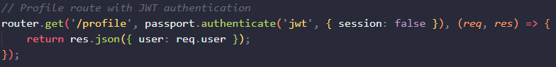

1. **Frontend (React)**
   * **HTTP requests:** In React, the Axios library, or in the case of the prototype application, the built in fetch API is used to communicate with the backend. The JWT token which is generated after the login process and stored in localStorage is included in the HTTP fetch request headers for protected routes to ensure proper authorization to those endpoints via the backend passport library as previously mentioned.

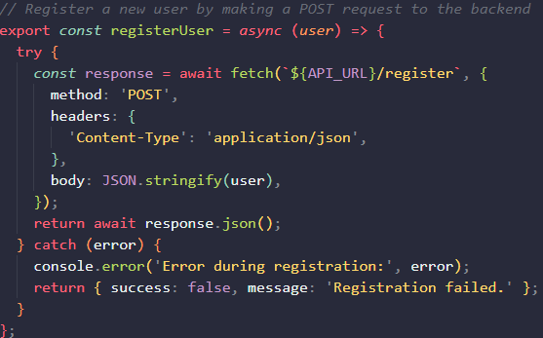

* + **Components and Authentication:** React uses useState hooks for data handling in forms and useEffects to fetch the profile data. Rendering of content is conditional based on whether the user is logged in and has a valid JWT, restricting route access using the built in react-router-dom for path protection. This helps to redirect users based on their login status.

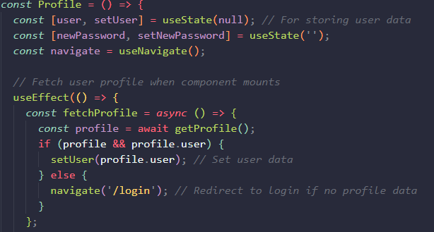

**Framework 2**: MEAN

1. **Backend:**
   * **User Model:** The User schema (userModel.js) is used to define fields such as name, email address, password and vouchers available. Mongoose is used to define the structure for the database and takes in these fields depending on what is entered in the registration form. There is a default value set to the vouchers for each new user receiving 10.



* + **Register route:** In the register route, the controller file (userController.js) checks if the email is already registered and belongs to an account in the database. If not, it hashes the password using ‘bcrypt’, creates a new user entry/document and saves it within the MongoDB database.



* + **Authentication:** JWT is used in the authenticate route, with the controller file first verifying the user’s email and password. If valid, it will generate a JWT using the ‘jsonwebtoken’ import and the secret stored in the .env file. The generated JWT has an expiration time of 6 hours (21600 seconds) which is set in the userRoute file.



* + **Protected routes:** In the prototype application, routes like /profile and /update use ‘*passport.authenticate(‘jwt’, { session: false })*’, as shown in the screenshot to ensure only authenticated users can access these endpoints. The update route then allows a logged in user to update their password but could be changed to allow for changes to any account specific information. This authentication route uses the passport middleware library and can then be applied to any routes/endpoints to ensure proper access levels to page content.



1. **Frontend (Angular)**
   * **Services:** Angular uses the built in ‘Httpclient’ service to send requests in to the backend for the registration, login and profile updates. The HTTP content is typically appended to the request headers and then returned as an HTTP method (Get, Post, Put, Delete) targeted at the specific route from the userRoute.js backend file. In the case of the register route, a post request is sent to http://localhost:3000/users/register with the user data in the header as seen in the screenshot below.

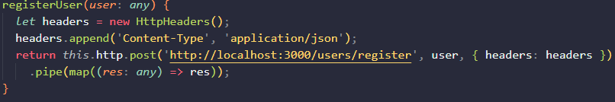

* + **Forms and Data Binding:** Angular uses a two-way data binding which makes it very easy to develop and handle user inputs in components like the registration and login forms. Angular also has tools for built in form validation to ensure that all fields are complete before submitting, although this wasn’t used to its full potential in the prototype and was replaced with a simple console alert

**Comparison:**

Angular (MEAN) provides a lot of built in tools and support for HTTP requests via HTTPClient and route guards which simplifies the development for authentication and using protected routes like the ones used for the user profile pages and data update routes. Angular’s CLI and use of typescript provides good structure for app development, making new component generation very simple and defining data types in the code as seen in the user model to provide integrity within the database. The use of these makes app setup, easier and more efficient.



React (MERN) on the other hand, tends to require more third-party libraries and acts more like a library itself rather than a framework. While in the prototype application, the fetch API was used for HTTP requests, React tends to use the Axios library and react-router-dom for routing and requests. Although this means React offers more flexibility, the lack of built in route guards means custom implementation is required to protect routes depending on user authentication status.



In terms of the user registration, login and profile authentication development, both frameworks work very similarly, especially considering the same backend/server side are used for the two prototypes. In saying that, I found angular to be easier in the initial app setup and with developing new components which is probably contributed to by angular acting like a proper framework with many built in tools compared to what react offers. The user registration and login were relatively simple to configure and maintain as Angular’s structure is very organized with services and guards that can be generated via the CLI. I found the development time for basic authentication app to only take a few hours, including implementing it with backend routes and JWT authentication.

For me, the MERN stack (Mostly React) required more time to configure and learn the structure of. React doesn’t offer many built in services out the box, like HTTPClient and auth guards. The development of both prototype applications were very similar to each other, but the file structure and development of the angular frontend was very simple and organized, making it nicer to work with. Angular CLI took a lot less time to generate and create all of the necessary files for each page compared to React which requires manual folder/file management and importing.

|  |  |  |
| --- | --- | --- |
| **Summary Table** | | |
| **Feature** | **MEAN (Angular)** | **MERN (React)** |
| **Ease of Development** | Angular CLI, HttpClient, built-in route guards | Requires Axios, react-router-dom, or built in fetch API |
| **State Management** | Two-way data binding services which are built in | useState, useContext, useEffects or Redux for state managment |
| **Form Validation** | Built-in validators with reactive/real time updating forms | HTML validation, custom logic for more complex forms |
| **Security and Performance** | Secure routing with guards and modularity. Not as flexible | Flexible but requires route protection |

### 2. Voucher Transaction

This feature allows users to redeem tokens via an interface (button), where each click of the button authenticates the user using JWT and if successful (they have a valid JWT), the token/voucher is then deducted from the user’s account.

In the final application, this feature would use JWT to manage the state of a user, with beneficiaries using the interface to acquire tokens/vouchers and then redeeming them using the same process as mentioned above. Charity members or donors can then accept a beneficiary’s redeemed token to finish the transaction.

**Framework 1**: MERN

1. **Backend:**
   * **User model/schema:** In mongoose, the user schema (userModel.js), includes a ‘vouchers’ field that stores the users available tokens. This value is updated during each voucher redeem process and will be used to manage beneficiary voucher amounts in the final application. Currently each new user is assigned 10 vouchers at default.



* + **Tokens redeem route:** the redeem-token route verifies the user’s JWT using the passport middleware library and is used in both prototype applications to ensure only authenticated users can redeem tokens and make requests to the database. If authentication is successful (the user has a valid JWT), it then checks the vouchers count in the database. If tokens/vouchers are available, it decrements the count and saves the updated value to MongoDB. Error handling and response messages are displayed via an alert/response, returning the new token count or an error if there are insufficient tokens to redeem.

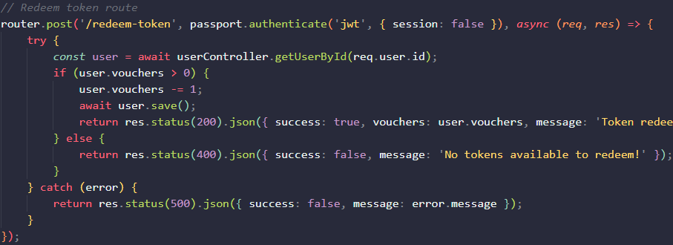

1. **Frontend (React)**
   * **Voucher redeem interface:** Similar to the angular component, the voucher redemption interface built in React, displays the users current voucher/token balance, with a redeem button that triggers the transaction.



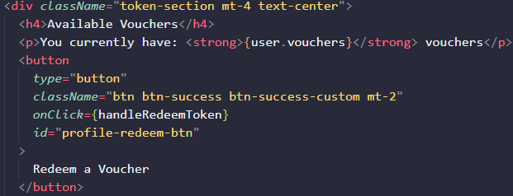

* + **API calls:** The Fetch API is used to send a HTTP request to the redeem-token route within the backend, with the user’s locally stored JWT being appended to the request headers for authentication. The response then updates the component/interface state to show the new token count and update in real time.

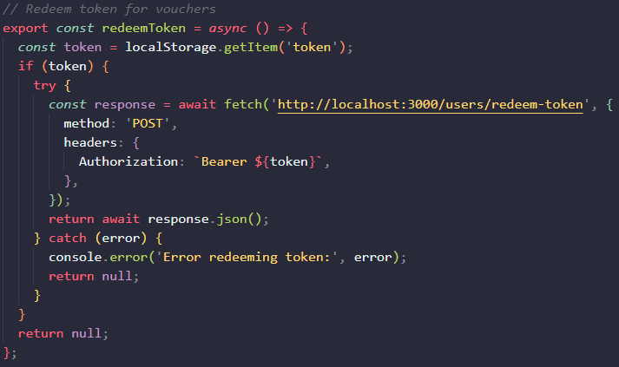

**Framework 2**: MEAN

1. **Backend:**
   * **User model/schema:** In mongoose, the user schema (userModel.js), includes a ‘vouchers’ field that stores the users available tokens. This value is updated during each voucher redeem process and will be used to manage beneficiary voucher amounts in the final application. Currently each new user is assigned 10 vouchers at default.



* + **Tokens redeem route:** the redeem-token route verifies the user’s JWT using the passport middleware library and is used in both prototype applications to ensure only authenticated users can redeem tokens and make requests to the database. If authentication is successful (the user has a valid JWT), it then checks the vouchers count in the database. If tokens/vouchers are available, it decrements the count and saves the updated value to MongoDB. Error handling and response messages are displayed via an alert/response, returning the new token count or an error if there are insufficient tokens to redeem.



1. **Frontend (Angular)**
   * **Voucher redeem interface:** Within the profile component/page, an interface in the form of a button and voucher counter display was added to reflect the amount of tokens available to the current user.



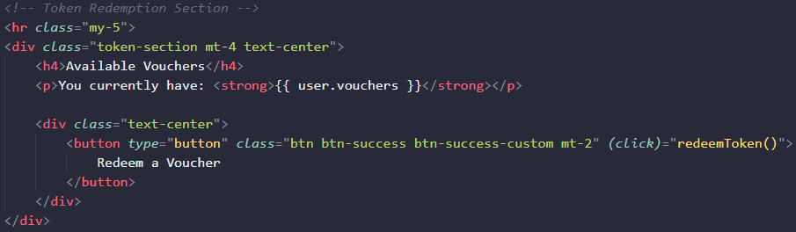

* + **Service:** The redeem voucher button then uses Angular’s HttpClient service to send a request to the redeem-token route with the JWT in the request headers for authentication. This is to ensure that the user is verified before redeeming a voucher. After receiving the server response, the component then uses the built in two-way binding to update the displayed voucher counter in real time.

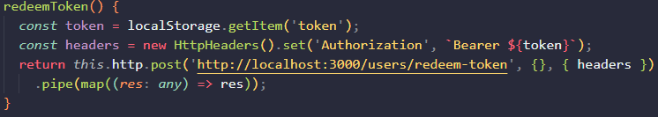

**Comparison:**

In the MEAN stack application, Angular helped to simplify the token verification, API requests and state management used in the voucher redeem interface. Token verification is managed with Angular’s auth guard and other built in services, allowing for tokens to be checked before a user tries to access specific routes. HttpClient provides a very straightforward way to send API requests and headers within the service layer of the application. Additionally, the interface is then updated in real time due to the two way data binding used in Angular applications to keep components synchronized effectively with the backend/database to ensure the voucher counter and other dynamically changing data are updated in real time after each transaction.

In the MERN stack prototype application, React handles token verification, API requests and state management with a slightly different approach. Token verification is often handled with conditional rendering based on the JWT which is stored in localStorage. This verification can involve additional setup but is managed by using libraries like Axios or the built in Fetch API for requests and token authentication.

In comparison, MEANs Angular tends to offer a more integrated, seamless and already built in approach to token handling and data synchronization with APIs due to the frameworks structure. I found this made the development more straightforward for authentication and state management. MERNs React, however, provides slightly more flexibility and modularity when it comes to implementing 3rd party libraries and other configuration requirements. Although this gives developers the ability to tailor the authentication for their application needs, Angular seems to have a strength with built in tools and existing data binding compared to Reacts adaptability and flexibility.

**Complexity Estimate**:

* **MEAN**: Developing the token redemption interface in MEAN was relatively straightforward due to the ease of development I found using Angular. An estimated development time for this feature is 1-2 hours, including backend route setup, JWT integration, and Angular component setup.
* **MERN**: The MERN implementation might have taken slightly longer as it involved a seemingly steeper learning curve with Fetch API calls and managing state updates with hooks. The estimated development time is 3-5 hours, although I feel this was exaggerated due to my lack of react knowledge.

|  |  |  |
| --- | --- | --- |
| **Summary Table** | | |
| **Feature** | **MEAN (Angular)** | **MERN (React)** |
| **Voucher Verification** | Route guards simplify secure access management | Conditional rendering and context-based |
| **API Requests** | Built in HttpClient service provides an easy way to send API requests | Axios or Fetch, with custom headers setup |
| **Interface State Management** | Two-way data binding for direct synchronization between backend and frontend | Hooks (e.g., useState, useEffect)for interaction between app layers |
| **Ease of Development** | Easy, built in tools with Angular services and guards | Flexible but can require additional 3rd party libraries for development |

### 3. Database Connection

This section involves storing and retrieving user data, such as account information, available vouchers/tokens and verification of user account existence in the database during the login process. The backend stores data in MongoDB, while the frontend retrieves and displays this data for authenticated users through API calls to specific routes.

**Framework 1**: MERN

1. **Backend:**
   * **User model/schema:** the user schema (userModel.js) in the Mongoose library is used to define fields like name, email, password and vouchers available. MongoDB stores this data, enabling all CRUD operations as needed by the application.



* + **Data retrieval:** the profile route retrieves user account details, when an authenticated user accesses their profile, the passport.authenticate middleware verifies the JWT and the controller (userController.js) fetches the data from MongoDB to display on the profile page. This includes user account name, email and available vouchers/tokens linked to the account.
  + During login, the authenticate route checks for an existing user by querying MongoDB with the provided email address. If the user exists in the database, it will proceed with the password verification and remainder of the login process. The screenshots below display the passport middleware used to create the JWT payload, the middleware used to secure other routes and the authenticate route used for the login process.

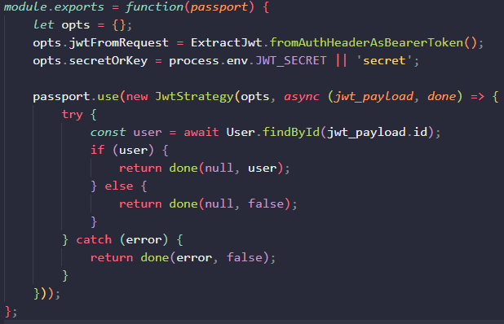



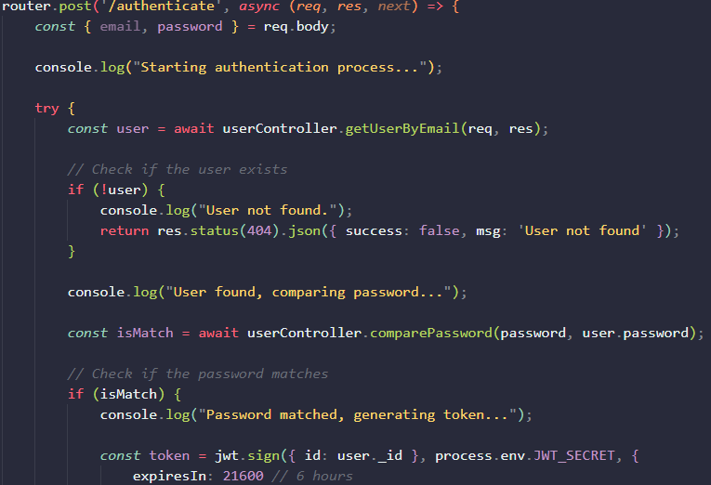

* + **Database Communication:** Mongoose library simplifies the database communication, allowing direct queries and updating of user data without needing complex SQL queries. MongoDB uses a NoSQL structure which is ideal for handling small application dynamic data like vouchers and user information, making update operations straightforward.

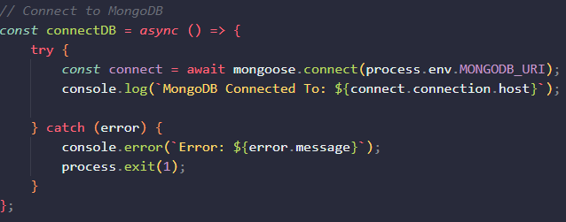

1. **Frontend (React)**
   * **Profile component:** the profile component built using React, retrieves user data using the Fetch API call, with JWT sent in the headers for authentication. The component then displays the user’s account information and voucher balance.

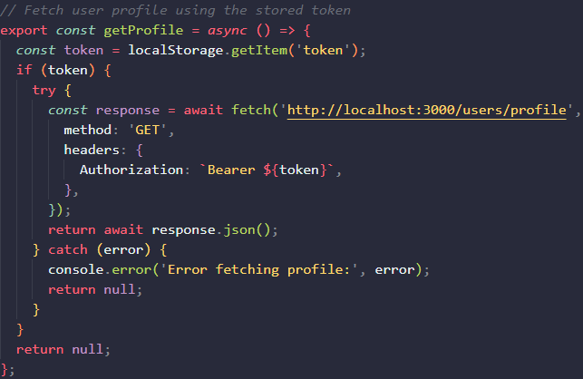

* + **Rendering:** with React, useState and useEffect hooks are used for the component to fetch and render user data dynamically. Conditional rendering is based, depending on the existence of a valid JWT, which is stored in localStorage upon a successful login.

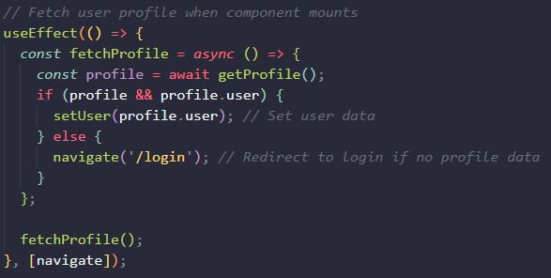

**Framework 2**: MEAN

1. **Backend:**
   * **User model/schema:** the user schema (userModel.js) in the Mongoose library is used to define fields like name, email, password and vouchers available. MongoDB stores this data, enabling all CRUD operations as needed by the application.



* + **Data retrieval:** the profile route retrieves user account details, when an authenticated user accesses their profile, the passport.authenticate middleware verifies the JWT and the controller (userController.js) fetches the data from MongoDB to display on the profile page. This includes user account name, email and available vouchers/tokens linked to the account.
  + During login, the authenticate route checks for an existing user by querying MongoDB with the provided email address. If the user exists in the database, it will proceed with the password verification and remainder of the login process.







* + **Database Communication:** Mongoose library simplifies the database communication, allowing direct queries and updating of user data without needing complex SQL queries. MongoDB uses a NoSQL structure which is ideal for handling small application dynamic data like vouchers and user information, making update operations straightforward.



1. **Frontend (Angular)**
   * **User profile:** the profile component fetches user information from the backend using Angular’s built in HTTPclient. JWT authentication is included in the request headers to ensure that user is authorized before being given access to their profile. The component then displays the data including, account name, email and vouchers available.Angular’s data binding keeps the displayed data synchronized with the component state, making real time updates almost seamless between the front and back end.

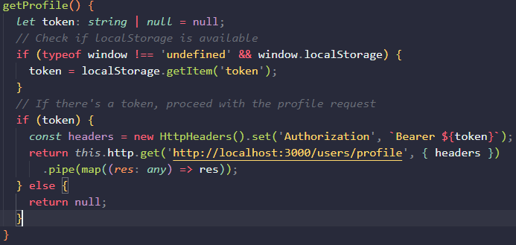

* + **Token Storage:** Both prototype apps store the JWT in localStorage, angular validates this through route guards when accessing the profile. Data retrieval for the profile is managed by a central Angular service, simplifying backend communication.

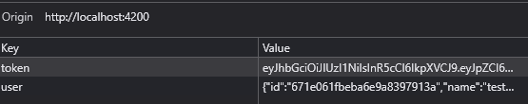

**Comparison:**

In the MEAN stack application, data retrieval is required and used throughout. Angular’s HTTPClient service helps to simplify this process along with data binding to smooth interactions between the backend and frontend. This ensures that components like the profile page stay synchronized with the backend data, and changes in the backend are automatically reflected on the frontend interface. In the prototype, this is only utilized with the display of user account data but will be particularly useful with donation listings and dynamically updating when donator’s manage listings to be reflecting on the beneficiaries end in real time.

In the MERN stack, React requires a little more setup for data retrieval due to have less built in tools compared to Angular. Typically, React uses Axios or Fetch for API requests and with the application, token validation is handled through conditional rendering depending on the JWT in localStorage, allowing customized access control to components/pages. React enables customized/more flexible solutions for state management but relies on hooks like useEffect and useState to retrieve, store, and display backend data. While React is more flexible, it does lack Angular’s built in and automatic data binding which can require developers to update state manually in components like the profile page.

**Complexity Estimate:**

* **MEAN:** Developing the storage and retrieval system in MEAN is relatively straightforward throughout the development of the prototype. Setting up these features, including in Angular and Mongoose queries was an on going process as many sections of the app require data storage and retrieval.
* **MERN:** The MERN implementation requires similar setup and configuration to the MEAN stack, but required more time to understand how React works with API calls to MongoDB. Since the prototype app uses data storage and retrieval throughout, the estimated time for development is hard to gauge, although did require more time than developing with Angular as I found the structure of React and how it works to be complex at times.

|  |  |  |
| --- | --- | --- |
| **Summary table** | | |
| **Feature** | **MEAN (Angular)** | **MERN (React)** |
| **Data Retrieval and State Management** | Centralized in built in services, easy with HttpClient | Axios or fetch api with hooks for managing state |
| **Profile Page and Data Display** | Two-way data binding for real-time updates | useState and useEffect for updates |
| **Ease of Development** | Structured with Angular services and guards | Flexible, but requires manual setup with libraries |

## Framework Recommendation

When developing a relatively complicated web application like the Grow & Give charity website which is aimed at facilitating and providing a platform for the donation of local fresh produce and food ingredients through donators and provide a voucher redeem system for community beneficiaries, selecting a suitable web solution or framework is crucial. After the design and analysis phase of the project, I evaluated both the MERN and MEAN stacks which involved research of their pros/cons and developing a simple prototype full-stack web application to compare the two frameworks against each other and identify the one most suitable for the Grow & Give charity websites development.

After evaluating both, I came to the conclusion that I would recommend the MEAN stack to build this project. While both stacks are more than capable of the projects scope and both using the same back-end technologies, I found that the MEAN stack and particularly Angular was easier to learn than React and I had a better time learning/understanding how it all works and is structured. Due to some previous projects using MongoDB, Express.js and Node.js, I picked up how to implement these into the prototype web applications relatively quickly and spent most of the time trying to understand both React and Angular, as that was a new experience. Although both frameworks that were evaluated use the same technology components (MongoDB, Express.js and Node.js), I appreciated how the MEAN stack worked together to create a scalable and easily maintainable web application with its reusable component architecture and file structure.

### React Pros and Cons

* **Pros**
  + Since React is more of a library rather than a framework, this allows developers to incorporate other libraries or third-party tools when needed
  + Uses and manipulates a virtual DOM which makes updates faster
  + Component based architecture which is great for making sure the code is reusable, scalable and maintainable.
  + Has a large community base and support system
  + Frequent an on-going updates to improve the React system
  + Open Source
* **Cons**
  + Less structured due to React not being a complete framework and more of a library, meaning there is less structure
  + Frequent updates to React could cause difficulties in keeping up to date with best practices
  + Developers need to choose and integrate additional tools for routing, validation and state management.

### Angular Pros and Cons

* **Pros**
  + Is a complete framework that offers everything already built in and has many functionality/features like routing, validation, http modules and state management from default
  + Binding makes synchronization between the data model and the user interface view simpler and more effective.
  + Typescript provides strong typing within the application to minimize errors and help to keep data integrity
  + Structured and scalable architecture which is useful for larger applications or projects
  + Open Source
* **Cons**
  + Steeper learning curve compared to React or Vue since Angular is more complex and comprehensive in its nature.
  + Less flexible since Angular is a complete framework and opinionated which can be restrictive if you want to mix and match third party tools.

### Justification for the MEAN Stack

Initially, I found working with Angular to be rather daunting due to its comprehensive nature and intimidating number of files within a newly installed Angular application but after research and working with it through tutorials/guides, I came to enjoy developing with the MEAN stack. As mentioned previously, the way Angular structures its component files and uses a simple component generation command to install a template for reusable features made learning and understanding how to create something meaningful quite quick. Additionally to this, I liked the way Angular and the MEAN stack links together to create a seamless full stack application that uses different routes and end points to display specific content. While using this framework to develop the prototype application, I very rarely got lost within the file structure and understood early on where things belonged and what each file was responsible for such as components having their own configuration, HTML and CSS files and the app files housing a lot of the global configuration for the app.

Other, more specific and detailed reasons for the recommendation of the MEAN stack included:

* **Framework Structure**
  + Angular seemed to have more depth, be a lot more comprehensive than React and act more like a framework by offering a defined structure for the development of apps. This can be beneficial in terms of the Grow & Give charity website If it grows over time and needs to expand the services provided as Angular’s architecture allows for easy scalability while maintaining consistency throughout the application. By organizing the project workspace into modules, services and components, it becomes a lot easier to manage, maintain, and update each specific part of the application independently.
* **Built-in tools**
  + Angular provides built-in tools and features such as routing, validation and http services which reduces the need for third-party libraries, essentially making it an all in one web solution. This approach from Angular leads to a faster, more efficient app development as many common and needed functionalities are already included in the framework. For the charity website, the development of key components will implement these built in tools such as routing for navigation between pages (registration, login, profile, etc) and form validation used in areas like the login, registration or when a donor creates a new donation listing.
* **Modularity**
  + Angular’s modular architecture promotes the development of individual parts of the application into separate components/modules. This is great for projects like the charity website as each feature (login, registration, navigation bar, etc.) of the website can be developed as separate components. Using this structure significantly improves the maintainability of the project, allowing developers to work on individual sections of the app without majorly affecting the rest of the website.
* **Angular CLI**
  + Linked to the modularity, Angular CLI provides tools for greatly speeding up the development process by allowing developers to generate components, services and modules quickly through running commands in the workspace. This is very useful when it comes to scaling the application as new features can be created with simple commands and means the new functionality can be introduced fast while following the same consistency and structure of the application, not to mention the ease of managing the folders and file structures.
* **Two-Way Binding**
  + Angular provides a way for real time synchronization between the back end data and the front end user interface in the MVC architecture (*Angular*, n.d.). For the Grow & Give website, this is particularly useful for dynamic elements that need to be live updating like creating new donation listings and the voucher acquisition/redeem system for beneficiaries. Any changes made by the user on the interface should in theory be immediately shown in the data model and vice versa.

### Conclusion

The MEAN stack is a strong choice for the development of the Grow & Give charity website, although the MERN is also a very close contender due to its similar architecture in the back end with the differences remaining in the front-end and how it connects to the rest of the application. Angular provides a modular structure and real time data handling with two way binding, along with the strong typing of Typescript which makes it ideal for a project that needs to maintain data integrity and a dynamic user interface (*Angular*, n.d.). With MongoDB for a easy to use and fairly scalable data storage, Express.js for the back-end management, Angular for the modern, responsive interface and Node.js for the server-side code. This combination makes the MEAN stack an ideal web solution and framework for developing the platform for the Grow & Give charity project.

# Develop – Milestone Three

## Part one: Functional Implementation of your website using your selected framework.

This section looks at the implementation of the proposed web application with the chosen framework and analyzes how it would have been achieved in the other framework used in the previous comparison (Evaluate stage).

### Register / Login / account Administration

**Backend:**

New users register through the /register endpoint which is handled by the addUser method from the userController.js file. Their name, email, selected role and password are sent in the request body where the addUser method checks whether an account is already registered under the provided email address. If the check is successful and the registration process continues, their password is hashed and salted using the bcrypt library before being stored in MongoDB to ensure secure storage of personal data.

A user’s role (either donor or beneficiary) is selected during registration, where if a beneficiary account is created, an initial voucher count of 10 is added. Donor accounts don’t get a voucher count but instead have the ability to add and manage donation listings through the donation dashboard. This feature was expanded on from the previous prototype application as before, there was only 1 kind of profile and 1 type of user role.

For the login process, the /authenticate endpoint is used to verify the entered credentials are valid against the stored credentials. Since the passwords are hashed and salted on registration, the bcrypt library is used to compare the passwords, and if correct, then it will generate a JWT containing the user id and role upon a successful login attempt. The JWT is signed with a preset secret key stored in the environment variable file. This assign JWT is then used throughout the application to ensure authorization and authentication to specific pages and components and to differentiate between user roles (donors and beneficiaries).

Once the user has successfully logged into their account and redirected, the /profile route retrieves the user’s information based on the token provided in the request headers. Users can then see their displayed account information (name and email address) and have the option to administer their accounts by the way of a password update. The /update route allows users to update their password, using bcrypt to hash/salt the new password before updating and storing it within MongoDB.

**Frontend:**

For the registration, a form is used to capture user details (name, email, role and password). A validation service is used to ensure that all fields are completed and the entered email format is valid. The frontend registration component is identical to the prototype application where it communicates with the backend using the auth service file to register the user. This service handles http request through the built in angular http client and handles any error feedback through the same method like duplicate email addresses in the database.

The Login form, similar to the registration form, collects the email address and password entered by the user and upon submission, it will send these credentials to the /authenticate endpoint via the auth service file and methods it contains. If the entered credentials match the stored credentials, the assign JWT and user data are then stored in local storage and the user is redirected to the profile page. The local storage is then cleared from any data when the user logs out or once a preset time of 6 hours has past, requiring the user to login again before accessing secure components/routes.

Each profile page has a section where user information is retrieved from the backend and displayed to the user based on the JWT stored in local storage from the login process. Users can use the input field and submit button to enter a new password which then uses the auth service to communicate with the /update endpoint to find and update the previous account password.

**Implementation comparison:**

The key differences between this implementation and the MERN stack implementation is the use of state management in the React frontend. As briefly found out through the prototype application, React uses features like redux for managing authentication state and user data across the application and instead of Angular forms and manual validation, React uses controlled components with useState or third party libraries for managing form state and its validation.

I also found that it is very common to have all of the component’s logic and interface within the same file. For example a registration component in React would have the methods for handling change or submit interactions as well as returning the “HTML” used to display the registration form. While this is still possible in Angular with the use of templating, I found the maintainability of separating logic from the interface and having dedicated html files easier to manage and understand where everything is or should be.

The backend for both frameworks/approaches remains very much the same as MERN/MEAN use the same technologies for handling routes and database management. A difference between the two (React and Angular) is in how they communicate with the backend routes, as Angular has built in tools for http communication where React typically uses the axios library or fetch API. State management for authentication would have also remained largely the same with JWTs being stored in cookies for local storage. React although has the ability to use redux for global authentication state.

### Donation Listing & Voucher Redemption

**Backend:**

When a user registers an account, the selected role is stored for that account and is added to the JWT upon a successful login process. This JWT with the role added is what is used to determine the content displayed on the profile page. Users with the donor role get a donation dashboard to manage donation listings and manage requested orders, and users with the beneficiary role have a section displaying the amount of vouchers/tokens they have and an order history displaying information regarding their order status.

The Product schema is used to define fields for a donation listing, including the donation name, description, location, image, stock and a donor id. The donor id field is a foreign key that links each donation to the donor who created it and is used to link orders back to the donor further down the line.

The addProduct method in the productController.js file allows authenticated donors/users to register a new donation. The controller methods retrieve product details from the request body and assigns the logged in users ID (req.user._id) from local storage to the donor id field for that donation listing. This is sent to the /add route which accepts POST requests for creating new listings. This route is protected with the passport JWT authentication ensuring only authorized use of this endpoint. An example of the add product method and route is below:

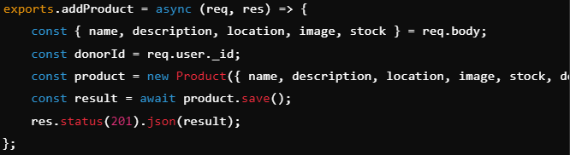



For beneficiaries, the user model used during the registration process includes a vouchers field that represents the number of tokens available to the user. Currently this is assigned a default value of 10 vouchers and there is no option for the user to acquire more tokens besides making another account. This isn’t a very good approach to the token acquisition feature and will likely change in the future of the application.

As for redeeming their vouchers/tokens, a specific method allows beneficiaries to redeem tokens by decrementing their balance and creating an order in the database based on which donation listing they were viewing and redeemed. An example of this method that is called within the product-details component can be seen below:

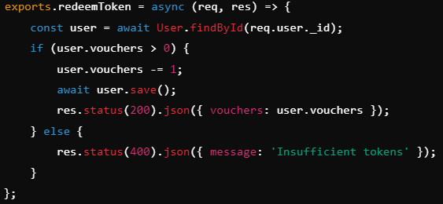

This approach was slightly changed from the prototype application as previously the redeem token method was used on the user profile and did very much a similar process. This was adjusted slightly and moved to the details page of the donation listing.

**Frontend:**

The donor profile component contains the interface for users with the donor role and contains the donor dashboard, where users can manage their donation listings and approve/decline orders from beneficiaries. Donors use a button is display a hidden form for the donation details. On submission, the addListing method from the component file, sends the data to the backend route using the product service file. The Product service manages API calls related to donation listings, including creating, retrieving and updating existing listings.

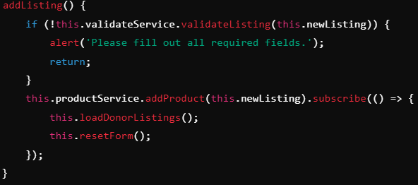

The beneficiary profile component is used to provide users with the role of beneficiary, an interface for their order history and access to view their current token balance. Beneficiaries redeem these tokens/vouchers by clicking on the redeem voucher button on the product details page, which runs a method to send a post request to the /orders endpoint, creating a new order, deducting a voucher from the user’s account and displaying that new order on the profile page.

### Interactive Elements

Some key interactive elements that have been implemented into the web application include the typewriter effect recipe generator using ChatGPT API, the different hover transition effects on donation listing cards and the smooth transitions for hiding/displaying donation listing details.

For the first element, the recipe generator allows users to input ingredients and generates a recipe using ChatGPT API. While the recipe is being fetched, a message of “thinking…” provides feedback to the user and keeps them engaged. Once the recipe is ready, it is then displayed character by character with a typewriter effect, adding more depth to the element and a sense of anticipation/engagement. The implementation of this was adding backend controller methods and routes to be used for communicating the frontend and backend. The recipe component takes input through a form and feedback messages are structured and formatted for easy reading. A deeper discussion of the recipe generator implementation can be found later on in this document.

The second mentioned interactive element is the hover transition effects applied to donation cards, meaning when the user hovers over each donation card with their mouse, the card slightly lifts upwards and gains a deeper shadow effect, making them stand out more. This enhances the user experience by providing visual feedback in real time, making the interface more interactive and polished. These hover effects were implemented in the products CSS file user the :hover tag. An example of this can be found below:

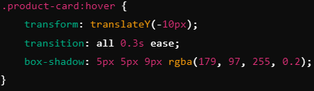

The third mentioned element is the smooth transition for hiding and revealing donation listing details. This element is used in the donor dashboard section of the profile page and allows donors to hide or reveal forms for creating or editing donation listings with a smooth animation, improving the user experience, usability and overall aesthetics. The frontend needed logic applied to both the HTML and CSS files with the HTML file making use of a ‘show’ class that is controlled via a button click. The implementation for this ‘show’ class is then added in the CSS file for the donor profile and an example of this can be found below:

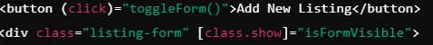

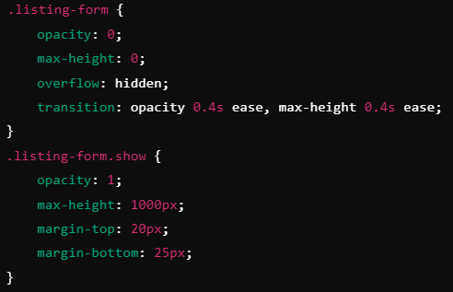

### Token Transaction

This functionality allows donors to manage transactions initiated by beneficiaries in the sense that donors can view pending orders and approve or decline them, updating the order status accordingly, automatically. Beneficiary’s vouchers are deducted once an order is created and refunded to that user if an order is declined for any reason. The system ensures smooth interaction between both user groups.

The current implementation for this is shown through the donor dashboard on the frontend, with the HTML structure of the donor profile component showing pending orders in a table, where each order includes detailed like the product name, customer name and the date of the order, along with buttons to approve or decline the order:

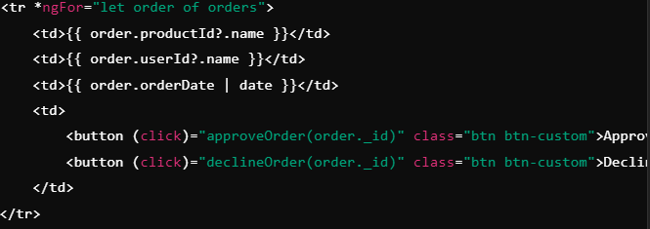

The logic for the donor side of the transaction included methods to load orders linked to the donor and options to update their status (approve or decline). These methods interact with the backend via Angular’s HTTP clients requests to both display orders from the database (GET request) and update their status (PUT request).

The orderController.js file has a method for updating the order status, whether that be approving or decline a beneficiary’s order. An example screenshot of this method can be seen below:

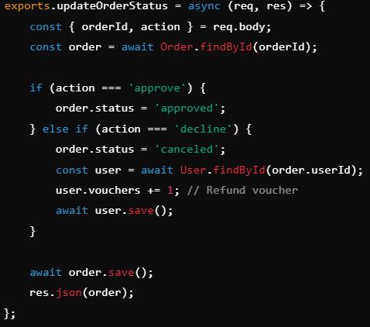

In terms of the beneficiary's side of the transaction, orders placed by the beneficiary are instantly displayed in the user’s profile (profile-beneficiary.component.ts). Each order placed shows the order ID, date created, status and product name within a table format. The logic that the beneficiary’s order component has involves retrieving the orders placed by a specific user from the backend, using the getUserOrders() method from the component file and can be seen below.

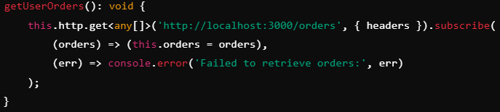

The backend orderController.js file contains a method for creating orders that is used within the product details file and is called via an HTTP request from the frontend once a beneficiary successfully clicks the redeem token button on a donation listing. This method handles order creation and deducts 1 one voucher/token from the beneficiary’s account upon a successful order creation. An example of this can be seen below:

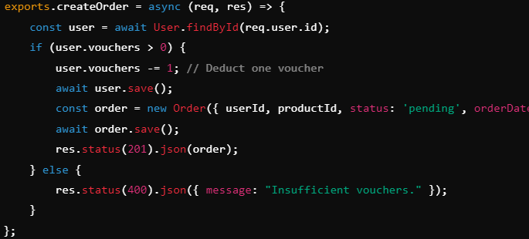

As far as additional work required beyond the original prototype application, almost all of the above features were required to properly achieve the needed functionality. In the prototype application, there was a transaction type process, although it wasn’t between two different user roles and didn’t correctly use JWT to handle the transaction.

The transaction section of the application could have been implemented differently if using the MERN web stack, specifically in the frontend, as the backend mostly remains the same. Within the existing application, Angular components and services handle API interactions and different state management. Whereas React uses functional components with hooks such as useState and useEffect to manage local state for orders and useContext for global user transaction state.

Improvement could be made to the user experience if React was used over Angular with the utilization of conditional rendering in React to provide instant visual feedback/updating with the likes of disabling the approve and decline order buttons while the API is making a request.

### Data Storage / Retrieval

The web application connects to a MongoDB database through the use of the mongoose library to ensure a reliable interface between the server and the database. In the current implementation with the MEAN stack, the mongodb connection is established using the mongoose.connect library method with its connection options within a dedicated config file that is ran during backend server start. The connection credentials are stored in an environment variable file to follow secure practices and uses event listeners for different connection events for better monitoring and debugging of potential errors.

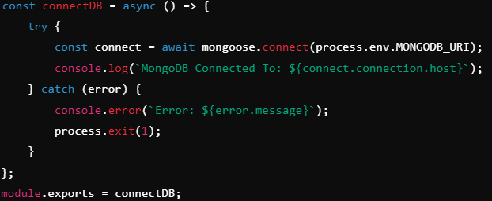

Mongoose schemas were implemented and used to structure different forms of data such as users, order or products to ensure proper integrity when storing and retrieving data. The use of schemas defines clear validation rules to ensure consistency between documents/records and allows for foreign keys like the use of the donor id field including a reference to the user model to establish a connection and allow retrieving associated donor details.

CRUD operations are implemented using mongoose’s built in methods live save, find, findByID, and findByIDAndUpdate. An example of this is add a product in the productController.js file using the product.save() method to save the result to the database:

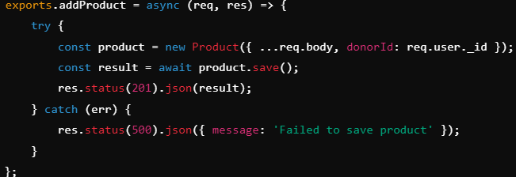

For retrieving data, the populate method of mongoose was implemented to ensure donation listing data has donor details attached to it to improve query usability. An example of this can be seen in the getDonorProducts method that uses the mongoose find method to get a specific donor’s donation listings:

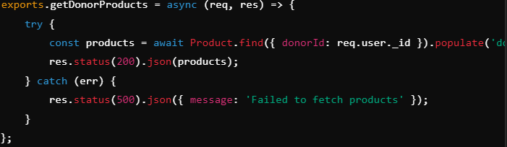

In terms of the differences of implementation between the two approaches (MERN and MEAN), there is almost no changes to be made as the data storage and retrieval is mostly handled through the backend which remains the same between the two stacks as they use the same technologies (Node.js, Express.js and MongoDB/mongoose). The main differences come from how the two stacks communicate with the backend routes/endpoints which retrieve and store data.

Lastly the connection method is invoked within the app.js file and is initiated during the application initialization to establish the database connection.

## Part two: research and implement emerging technology into your website

An emerging web technology is a new software innovation that has potential to impact the way websites or web applications are developed, delivered or interacted with by its users. These emerging web technologies are intended to meet the constantly evolving needs of both developers and users, often changing how services are designed which can create a more advanced, accessible and user-friendly web application or website (Kundariya, 2024).

Many modern emerging technologies often have APIs or code libraries that can be integrated and implemented into other applications or systems. These APIs/libraries act as an abstract to hide the complex processes of the technology, letting developers worry less on the third party technology and focus more on building their application without needing a deep understanding of the tool itself.

Implementing AI or LLMs (Large Language Models) require APIs for communicating with the service and can be used for chatbots or generating personalized content. Tools like ChatGPT and Llama AI have become incredibly popular and have been used more and more by developers to help with content creation or to replace traditional customer support methods (Murphy, 2024). ChatGPT API provides access to the powerful LLM, allowing applications to generate text, answer user inquiries or even perform text based tasks. This works by developers creating a method to send an HTTP request to the API with their desired prompt, the API then processes the input using the preset language model (4o mini, 3.5 turbo, etc.) and returns a response.

A brief example of an emerging technology that provides developers with code libraries is TensorFlow for machine learning. TensorFlow is used within Python and/or JavaScript applications for AI and machine learning, letting developers use the code libraries for access to predefined models or to create custom ones for tasks like image recognition, voice processing and analytics.

### Supporting code systems and implementation

The ChatGPT Large Language Model was implemented into the 2 sections of the project web application, firstly by incorporating a recipe generator feature that beneficiaries can use to create custom recipes based on the produce ingredients they receive from a donation listing or food package. This feature enhances the accessibility and usability of the application, especially for users that receive food donations and may need help with figuring out how to use or cook with certain ingredients.

The second requirement that has been supported by the implementation of ChatGPT API is within the donation listing creation/editing process. Donors have the option to generate a detailed description of the listing item, similar to the recipe generator. This supports donors during the process of managing their donation listings, saving their time and improving user experience via enhanced usability. Donors that don’t want to use the description generator can still manually enter their own description or adjust the generated text to their liking.

**Supporting Code Systems:**

to Implement this feature, many of the existing code systems needed adjusting/updating to allow for the integration of the LLM. A breakdown of the backend and frontend changes is included below:

1. **Backend:**
   1. **Controllers:** Two controller files were needed to handle requests for the ChatGPT API and construct a prompt that is sent. The recipeController.js file gets a response that provides a detailed recipe based on the user input ingredients and formats it into readable HTML. The descriptionController.js file generates a description response that can be used for donation listings based on a brief summary provided by the user.

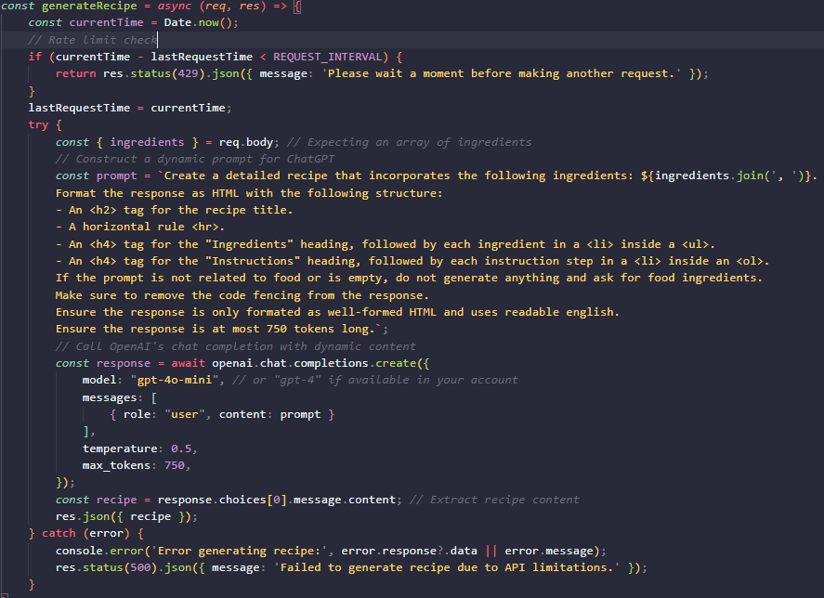

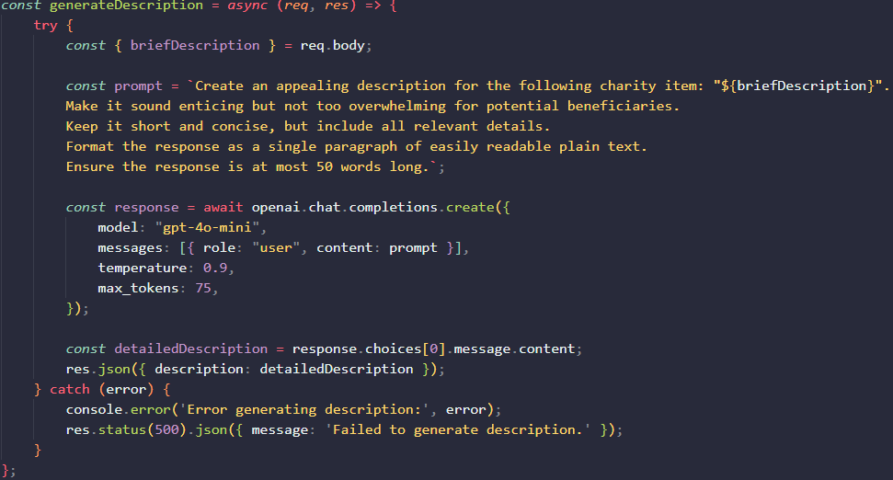

* 1. **Routes:** Two new route files were created to separate secure endpoints from the logic behind them. Both routes used passport JWT authentication to ensure only authorized users with a valid token can access these routes. recipeRoute.js handles the recipe generation. descriptionRoute.js handles the listing description generation
  2. **API configuration:** The backend controller files, use OpenAI’s GPT 4o mini model, which is their cheapest model while still offering great response times and capabilities. Each request uses a preset structured prompt that is tailored to the specific feature/component. The recipe controller implements a rate limit to prevent excessive requests to the API by using a 3 second pause interval between requests made.

1. **Frontend**
   1. **Components/Pages:** recipe.component.ts provides the user with an interface specifically for recipe generation. Beneficiaries or any authorized user of the app can enter input ingredients which submits a request to the backend and displays the API response recipe in a container with a typewriter effect for design depth. The existing profile-donor.ts component implements the donation listing generation by allowing donors, to input a brief name or summary of their listing in the add/edit listing form to generate a detailed description using the previously mentioned backend process.
   2. **Error handling and UI:** Both components that incorporate the ChatGPT API display informing alerts for errors like invalid inputs, too many requests or API failures. A ‘thinking…’ message is also displayed while waiting for the API response to improve user experience and let the user know the API is processing.

**Implementation:**

1. **Backend:**
   1. Installed the OpenAI dependency using npm install in the repositories rot directory and then created and configured the need environment variables (.env) for the OpenAI API key. The API key was generated on the OpenAI website using my personal account.
   2. I then followed the implementation guide on the official OpenAI API website which lead to me creating the necessary methods for sending a request with desired prompt for the API. For this I created the previously mentioned controller files (recipeController.js and descriptionController.js) to both parse ingredients and send them as a prompt and receive the response as html and process the brief listing summary to generate a detailed, enticing listing description.
   3. Routes were then added with secure JWT authentication to ensure only authorized users can access these features:





1. **Frontend**
   1. **Recipe generator:** A dedicated component was created using the Angular CLI generate component command, which is protected using the locally stored JWT token to provide authorization to the page. The user provides ingredients in the input box within the form that then gets processed and sent to the /recipes endpoint for the response to be displayed at the bottom of the container with a typewriter effect. A screenshot of the generateRecipe method within the frontend component can be seen below:

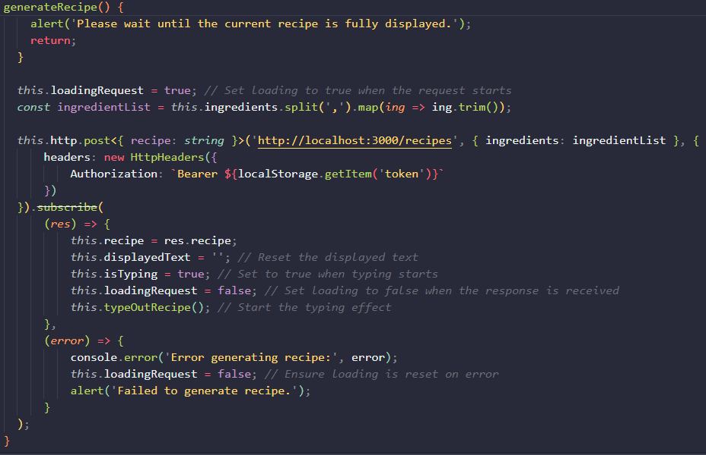

* 1. **Description generator:** The description generator component was implemented into the existing donor profile component. The donor profile houses a form for users to add new donation listings or edit existing ones. This form then has a section for a listing description to be entered that describes the donation for beneficiaries to understand what is being offered.The donor user inputs a short summary of the donation listing into the description text area. This is then sent to the /description endpoint and the generated description response is displayed within the description text area for that donation listing. The user can then update or adapt the generated response to their liking or discard it and use their own description. A screenshot of the generateDescription method within the donor profile can be seen below:

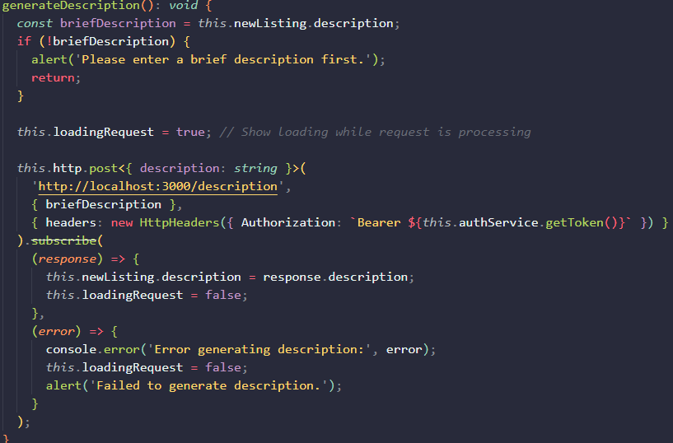

**Purpose of Recipe generator:**

The purpose and reason for implementing the recipe generator is to allow beneficiaries a way of better understanding and using the acquired, donated food items. The recipe generator provides tailored recipes based on the ingredients entered by the user and means even is users don’t have knowledge on the ingredients and/or food items they receive from a donation, they can still utilize them.

As mentioned previously, users, or more specifically, beneficiaries enter a list of ingredients or food items that are separated by a comma into the input box and the ChatGPT API, generates a detailed recipe with sections for ingredients and instructions on what to do, all formatted into readable HTML.

An example is the input of “potatoes, onions, carrots.” The response is formatted as HTML so it can be displayed well on the frontend:

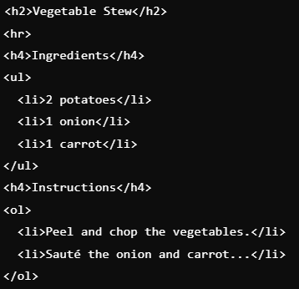

**Purpose of Description generator:**

The purpose of the description generator is to help donors create enticing and detailed descriptions for their donation listings. Using a more detailed description for their donations improves the visibility and potential appeal from beneficiaries on the platform

As mentioned previously, donors enter a brief summary or description of the item the listing is for (fresh raspberries for example) and the ChatGPT API then responds with a generated, detailed description tailored to their donation listing. Donors are then able to adjust or remove any part of the description they want or even skip over this feature entirely.

An example input and response for this feature includes the description input of ‘fresh raspberries’ with the API output returning something similar to: “*Delicious, freshly picked raspberries bursting with natural sweetness. Perfect for desserts, smoothies, or a healthy snack*!”

# References

*Angular*. (n.d.). <https://v17.angular.io/guide/binding-overview>

Kundariya, H. (2024, August 1). HubSpot. *11 web development trends to expect in 2024, according to experts & data*. <https://blog.hubspot.com/website/web-development-trends>

Langley, K. (2024, August 14). *The evolution of the web and the rise of LLMs*. <https://www.linkedin.com/pulse/evolution-web-rise-llms-kent-langley-ubasc/>

Murphy, C. (2024, February 21). Prismic. *10 Top Web Development Trends to Watch in 2024*. <https://prismic.io/blog/web-development-trends>

*Progressive web apps | MDN*. (2023, October 25). MDN Web Docs. <https://developer.mozilla.org/en-US/docs/Web/Progressive_web_apps>

Sheldon, R. (2023, June 26). *web development framework (WDF)*. Content Management. <https://www.techtarget.com/searchcontentmanagement/definition/web-development-framework-WDF>

Stewart, E. (2023, January 26). The death of the customer service hotline. *Vox*. <https://www.vox.com/23571375/no-call-center-phone-number-frontier-facebook>

Technologies, I. (2024, April 1). What are web frameworks and why you need them? - Intelegain Technologies - Medium. *Medium*. <https://intelegain-technologies.medium.com/what-are-web-frameworks-and-why-you-need-them-c4e8806bd0fb>

*WebAssembly | MDN*. (2024, April 16). MDN Web Docs. <https://developer.mozilla.org/en-US/docs/WebAssembly>